**MYSQL ALL QUERIES**

**Q1: CREATE THE ABOVE TABLE**

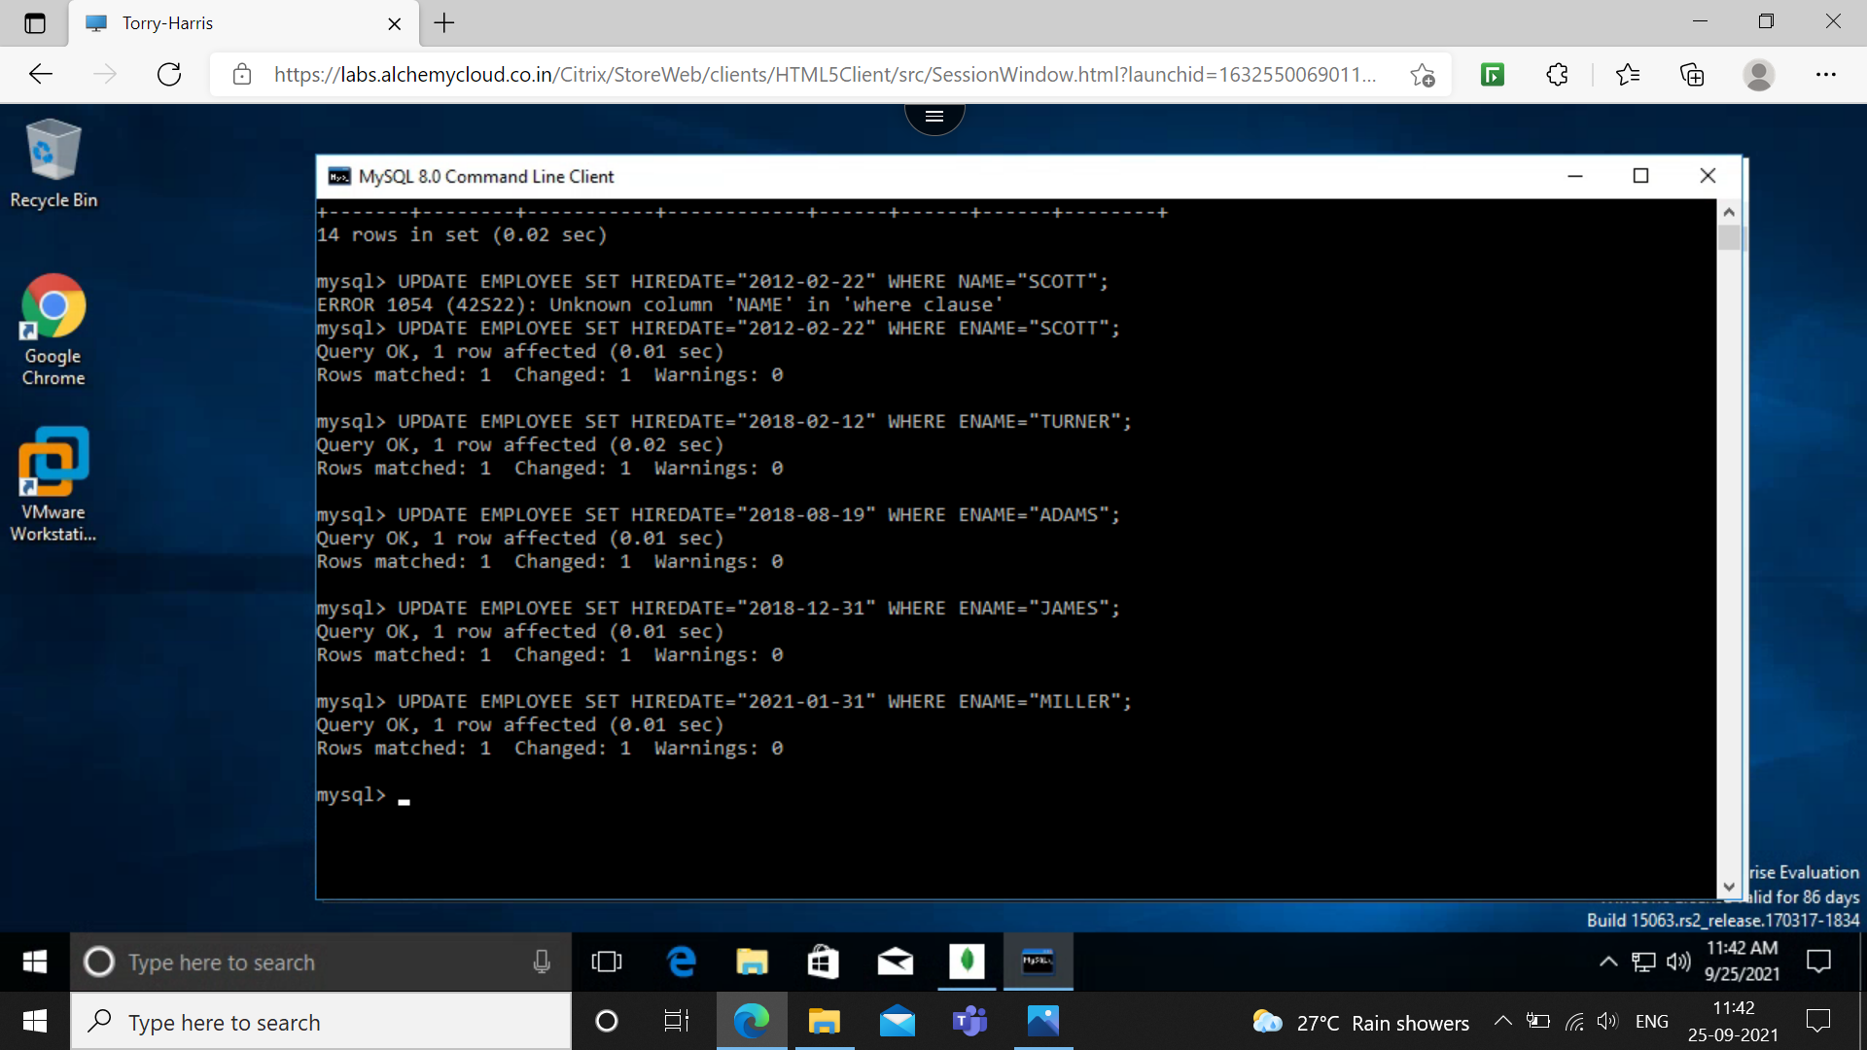

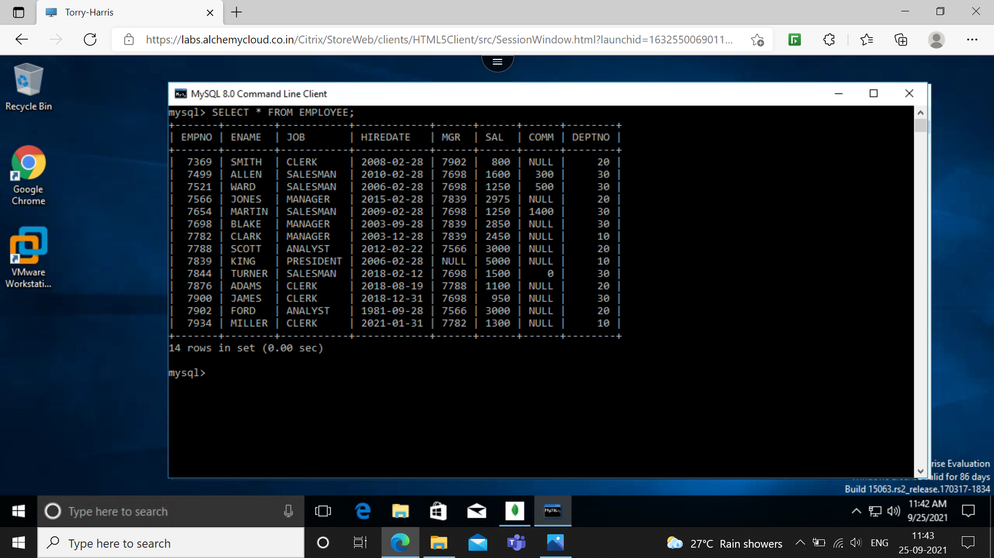

**Q2: SELECT THE EMPLOYEE IN DEPARTMENT 30**

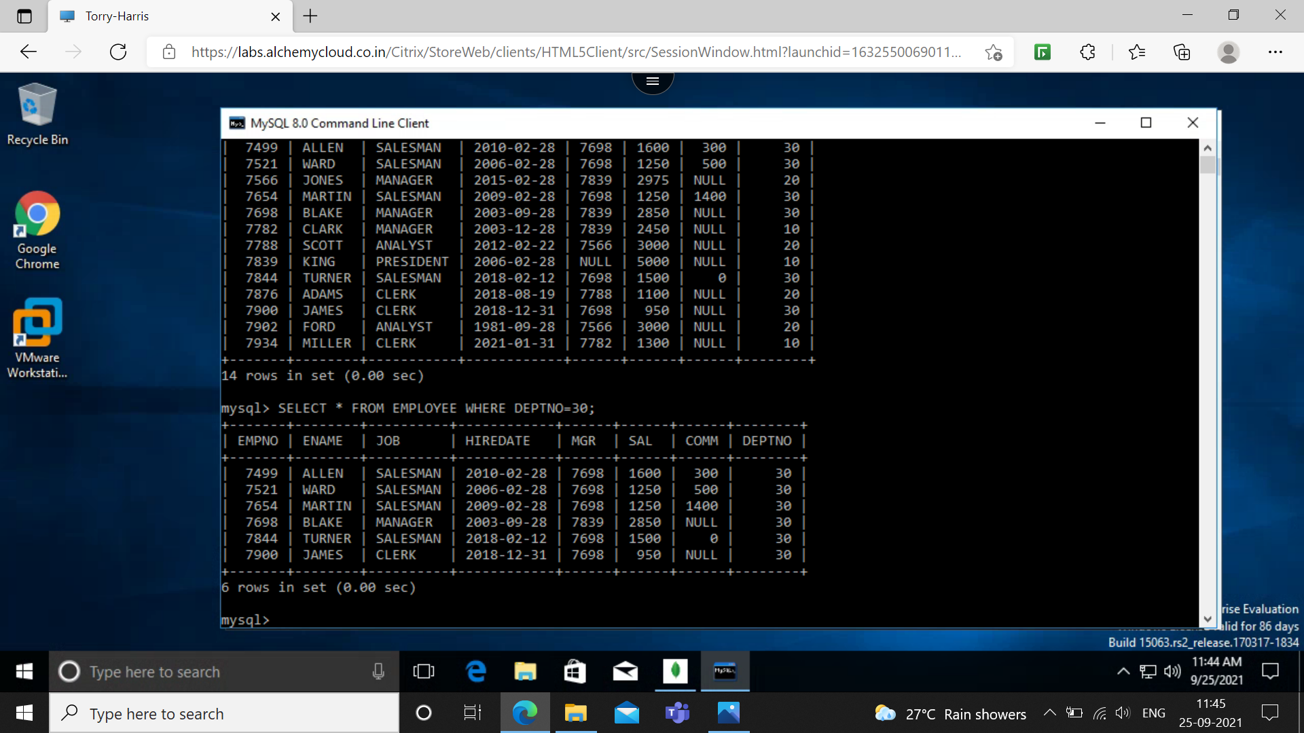

**Q3: LIST THE NAMES,NUMBERS AND DEPARTMENTS OF ALL CLERKS**

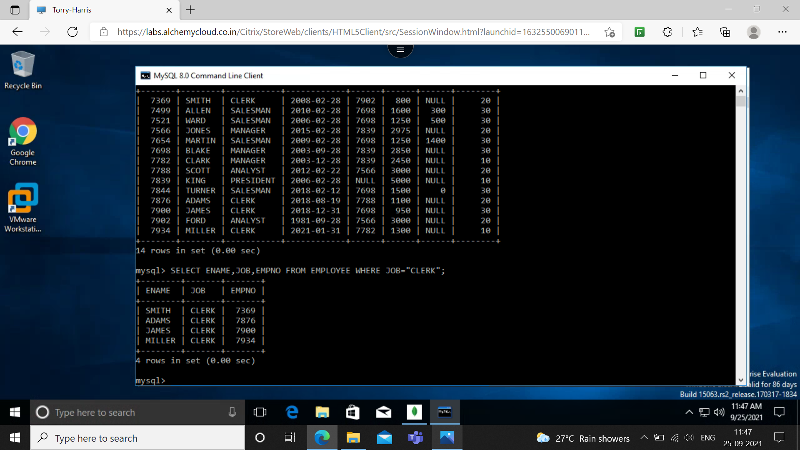

**Q4: FIND THE DEPARTMENT, NUMBERS, NAMES OF EMPLOYEES OF ALL DEPARTMENTS WITH DEPTNO GREATER THAN 20.**

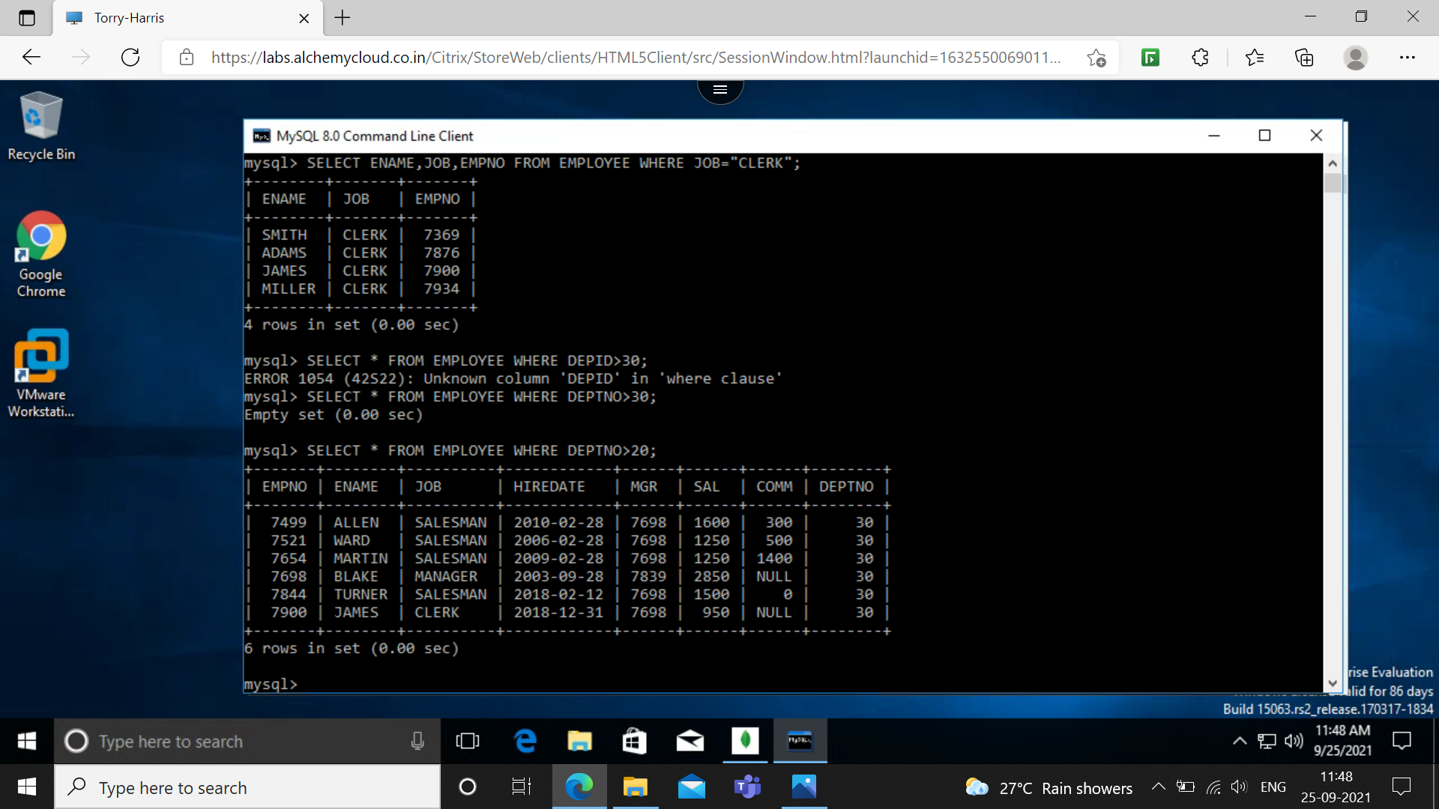

**Q5: FIND EMPLOYEES WHOSE COMMISION IS GREATER THAN THEIR SALARIES**

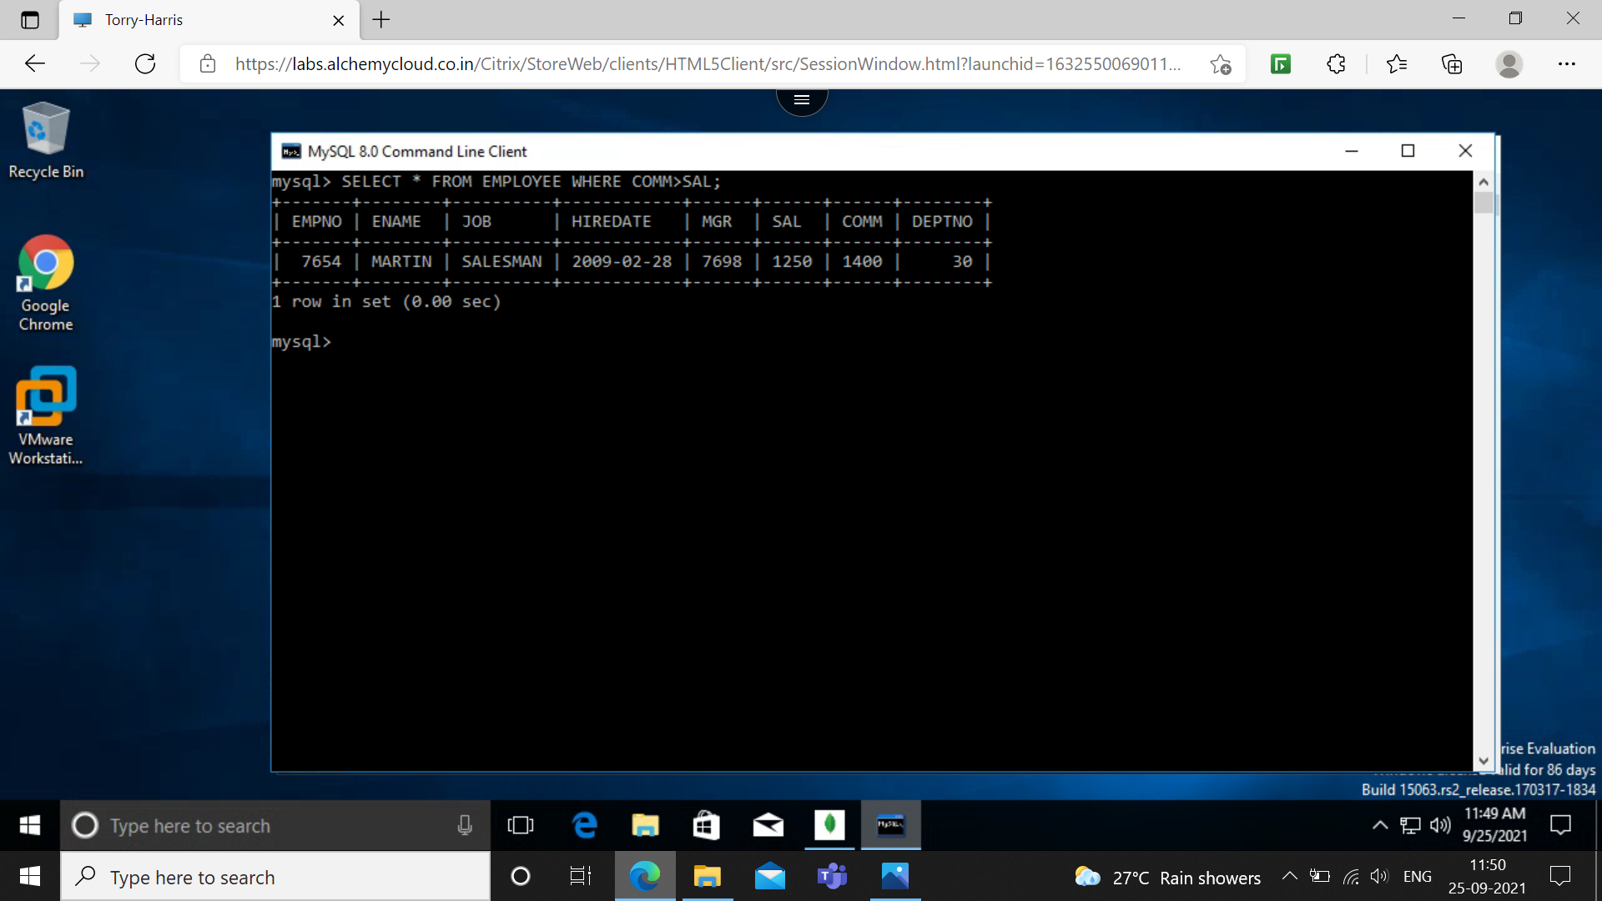

**Q6: FIND EMPLOYEES WHOSE COMMISION IS GREATER THAN 60% OF THEIR SALARIES**

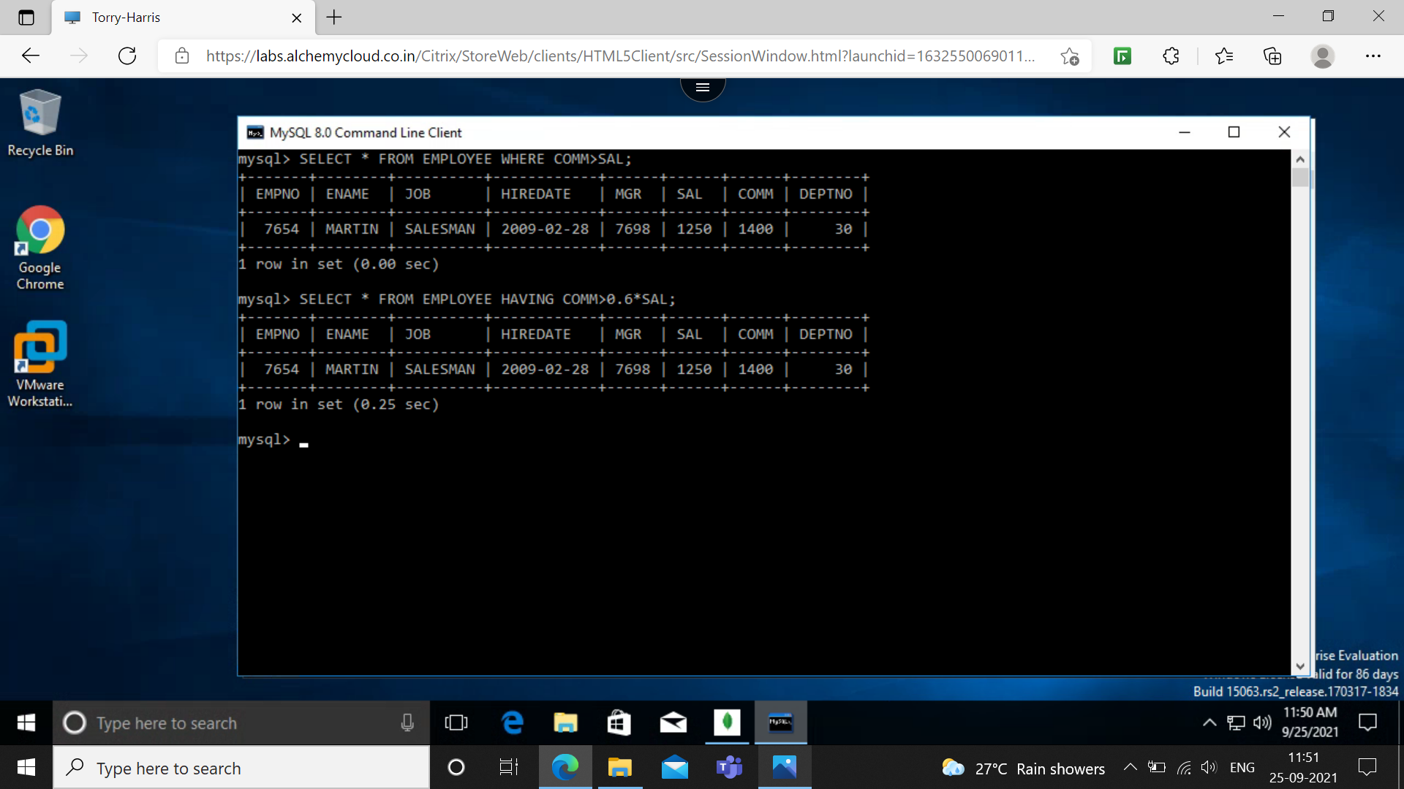

**Q7: LIST NAME, JOB AND SALARY OF ALL EMPLOYEES IN DEPARTMENT 20 WHO EARN MORE THAN 2000.**

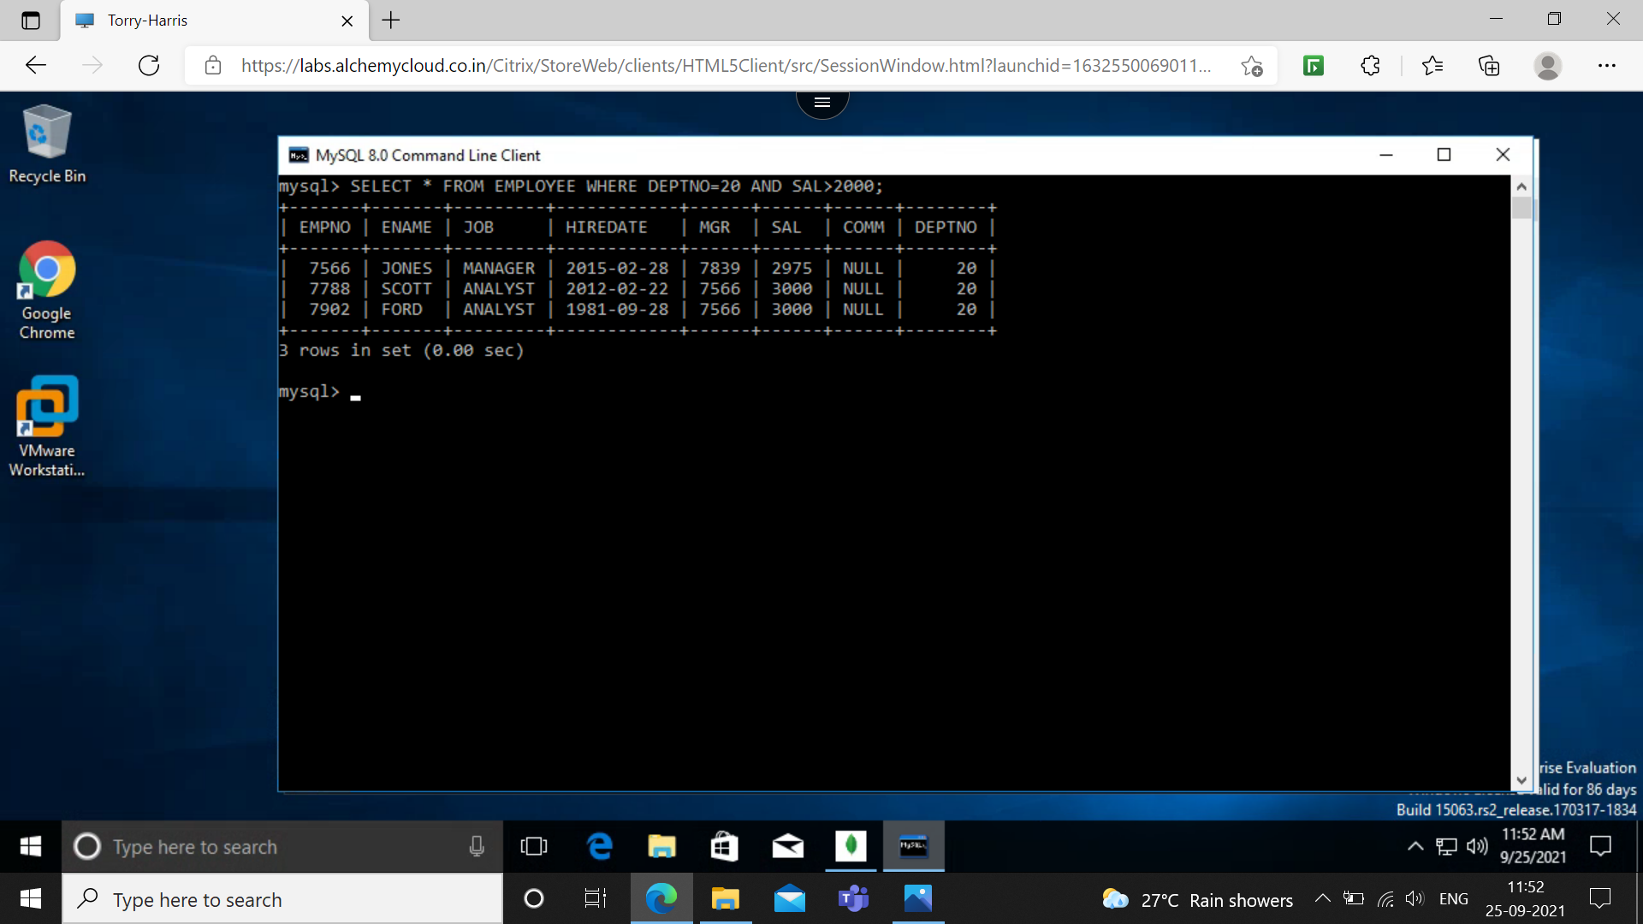

**Q8: FIND ALL SALESMAN IN DEPARTMENT 30 WHOSE SALARY IS GREATER THAN 1500.**

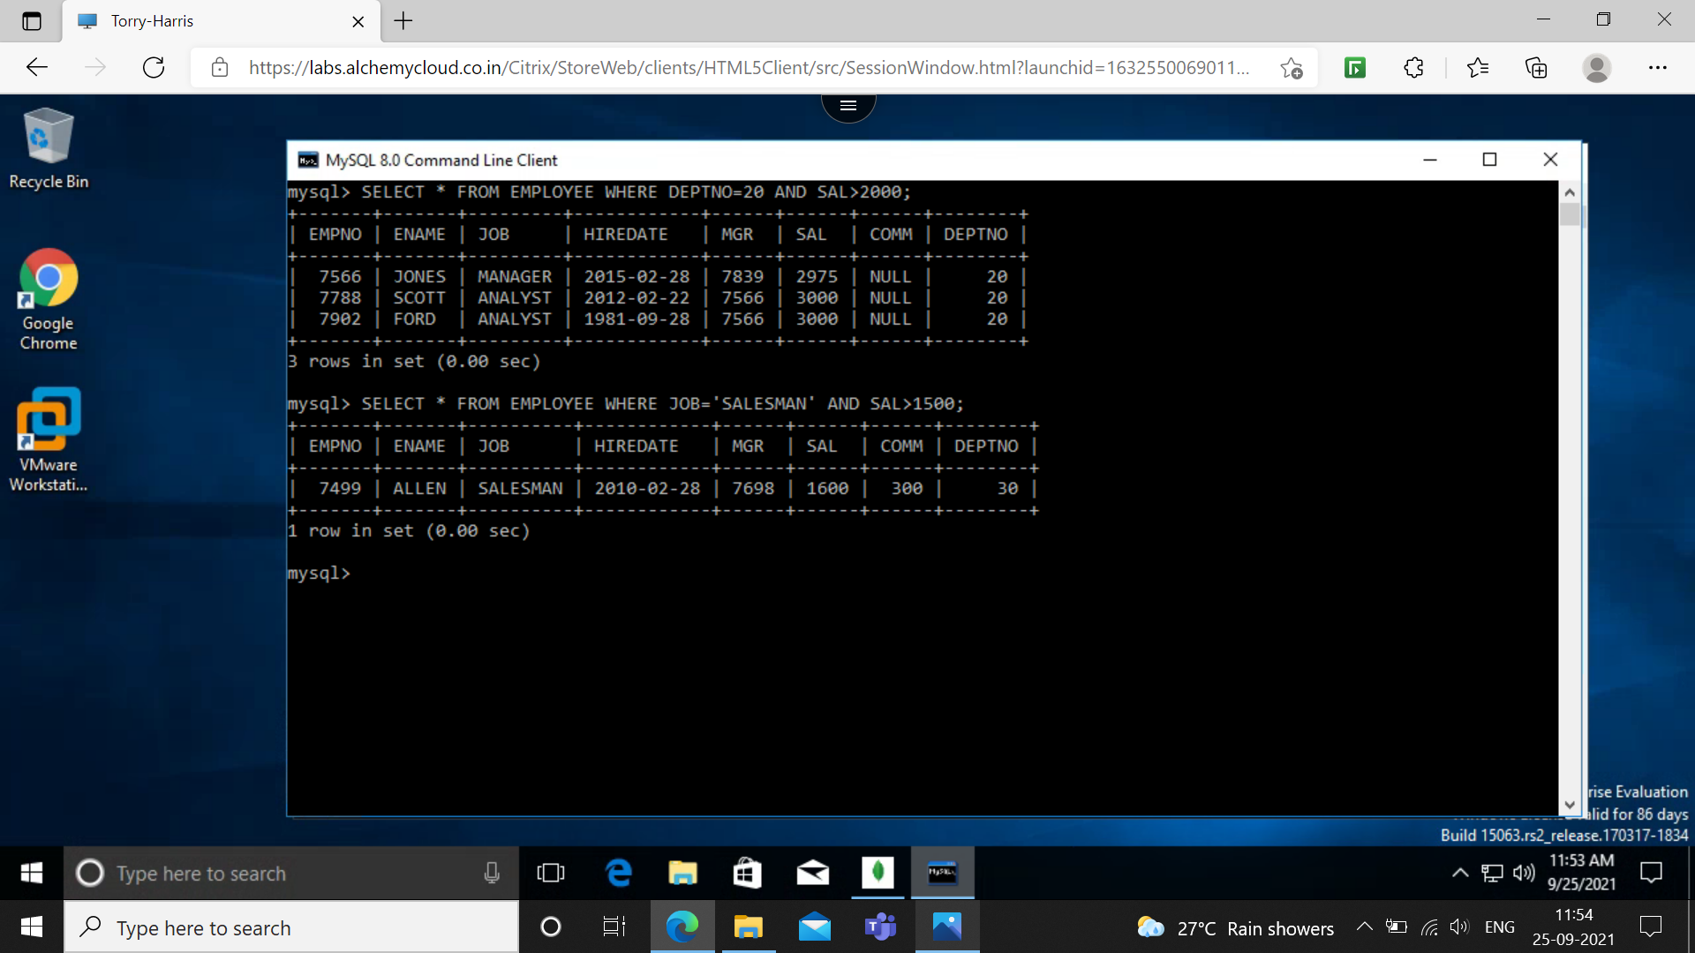

**Q9: FIND ALL EMPLOYEE WHOSE DESIGNATION IS EITHER MANAGER OR PRESIDENT.**

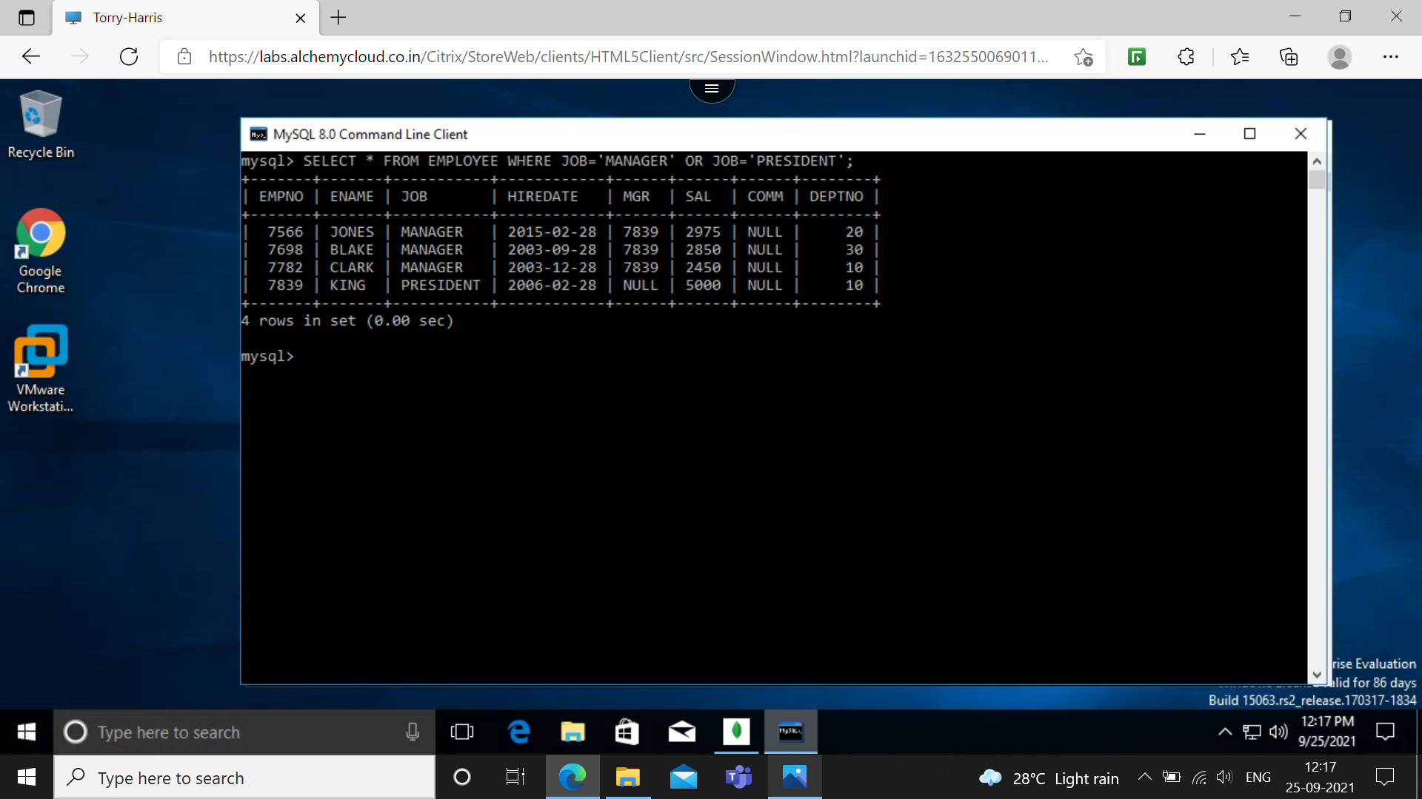

**Q10: FIND ALL DETAILS OF MANAGERS IN DEPT 10**

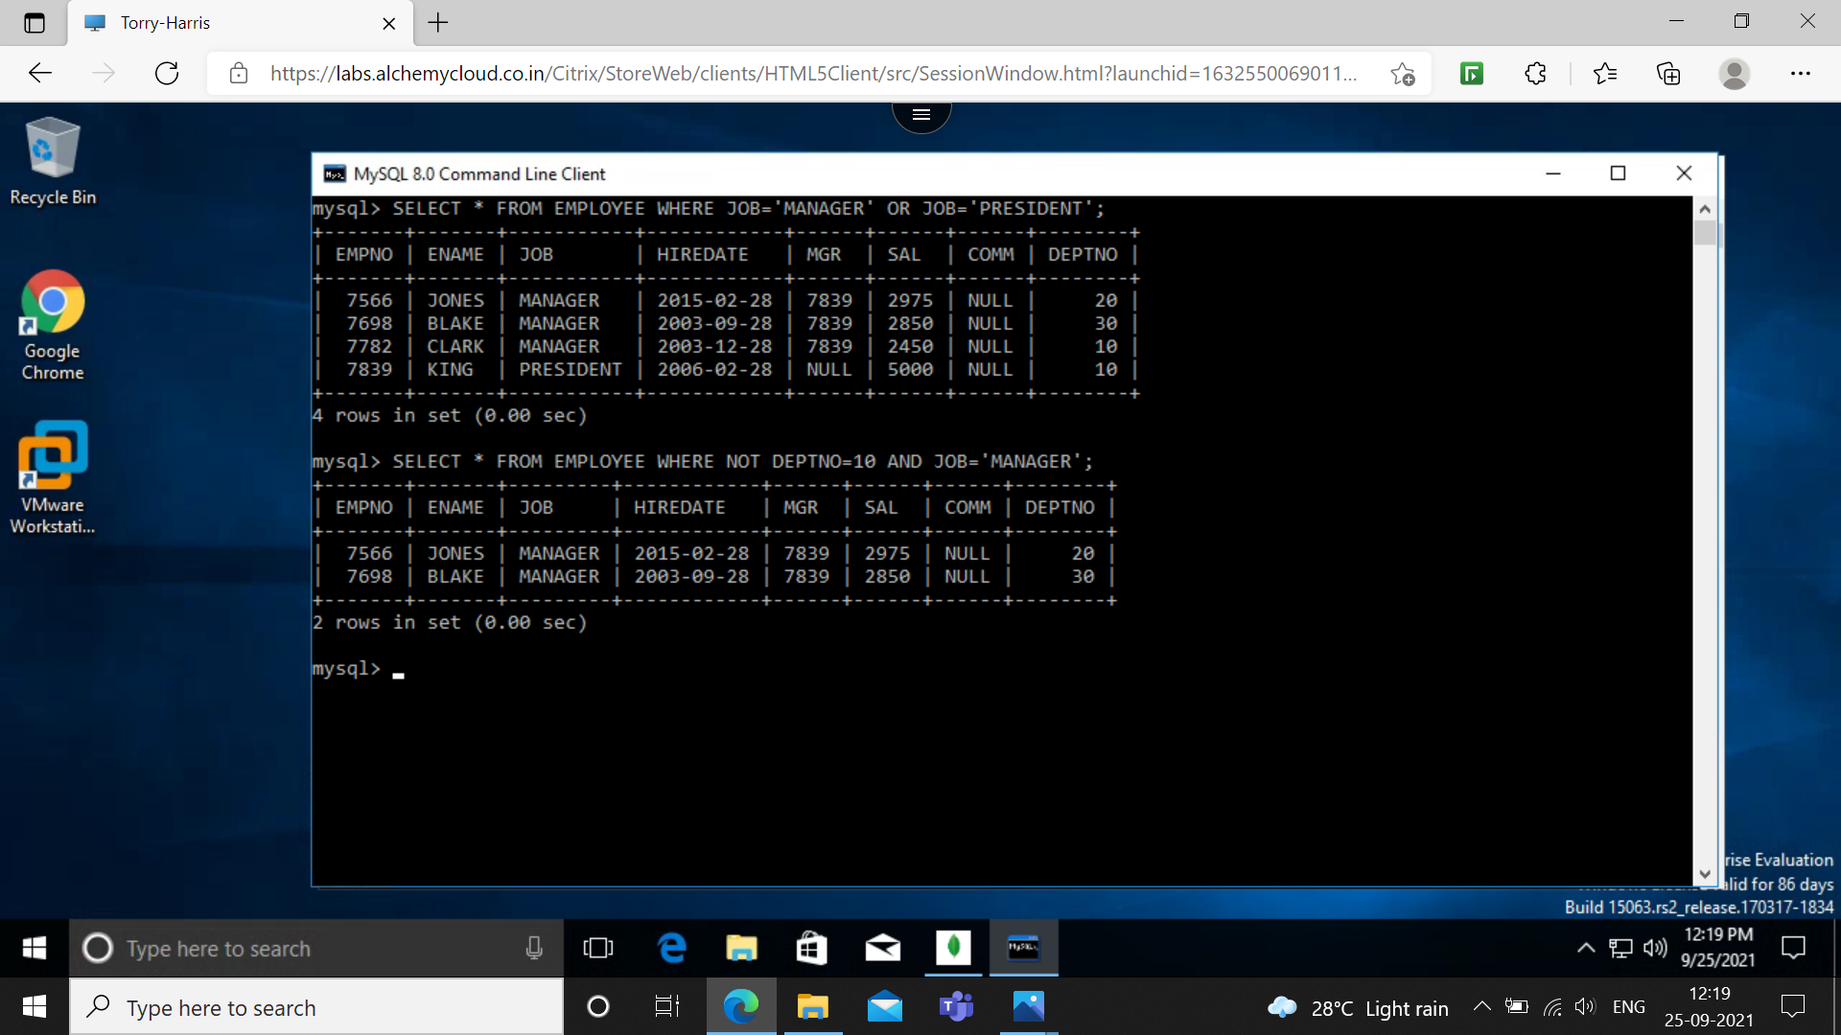

**Q11: FIND ALL DETAILS OF MANAGERS AND CLERKS IN DEPT 10**

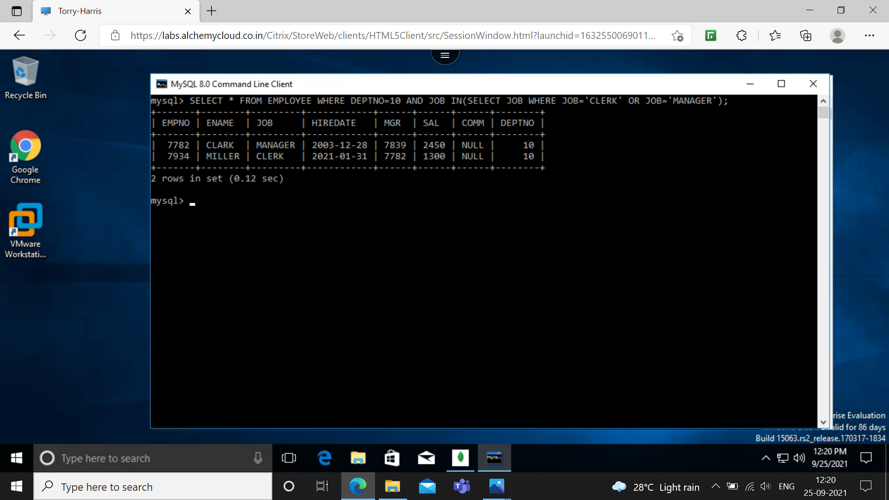

**Q12: FIND THE DETAILS OF ALL THE MANAGERS (IN ANY DEPT) AND CLERKS IN DEPT 20**

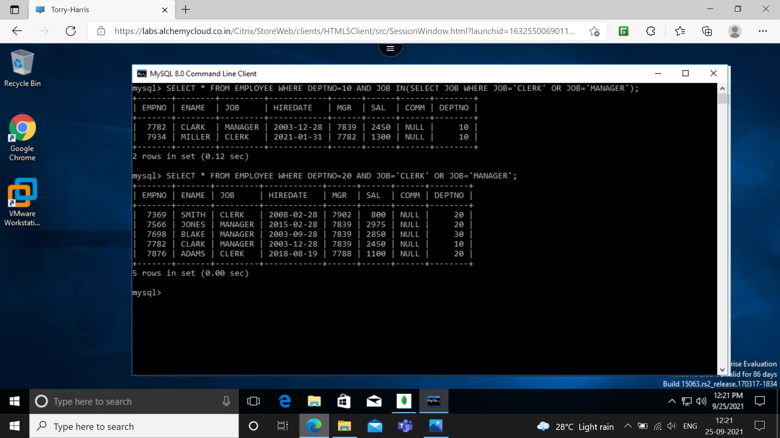

**Q13: FIND THE DETAILS OF ALL THE MANAGERS IN DEPT 10 AND CLERKS IN DEPT 20 AND ALL EMPLOYEES WHO ARE NEITHER MANAGERS NOR CLERKS WHOSE SALARY IS MORE THAN OR EQUAL TO 2000.**

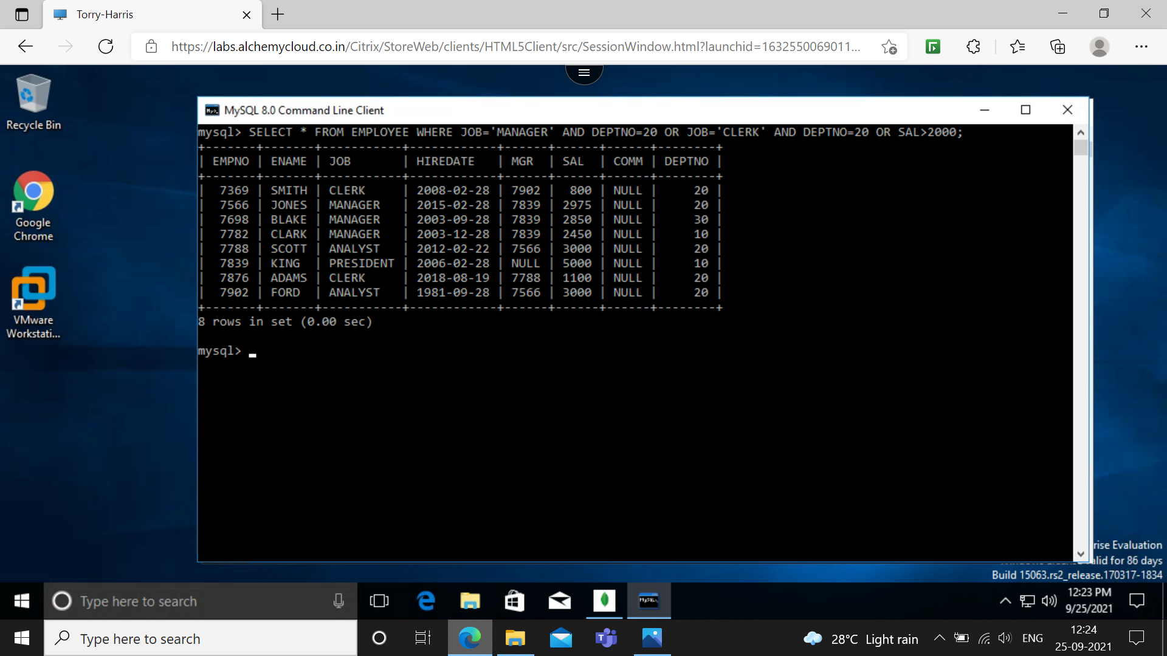

**Q14: FIND THE NAMES OF ANYONE IN DEPT 20 WHO IS NEITHER MANAGER NOR CLERK.**

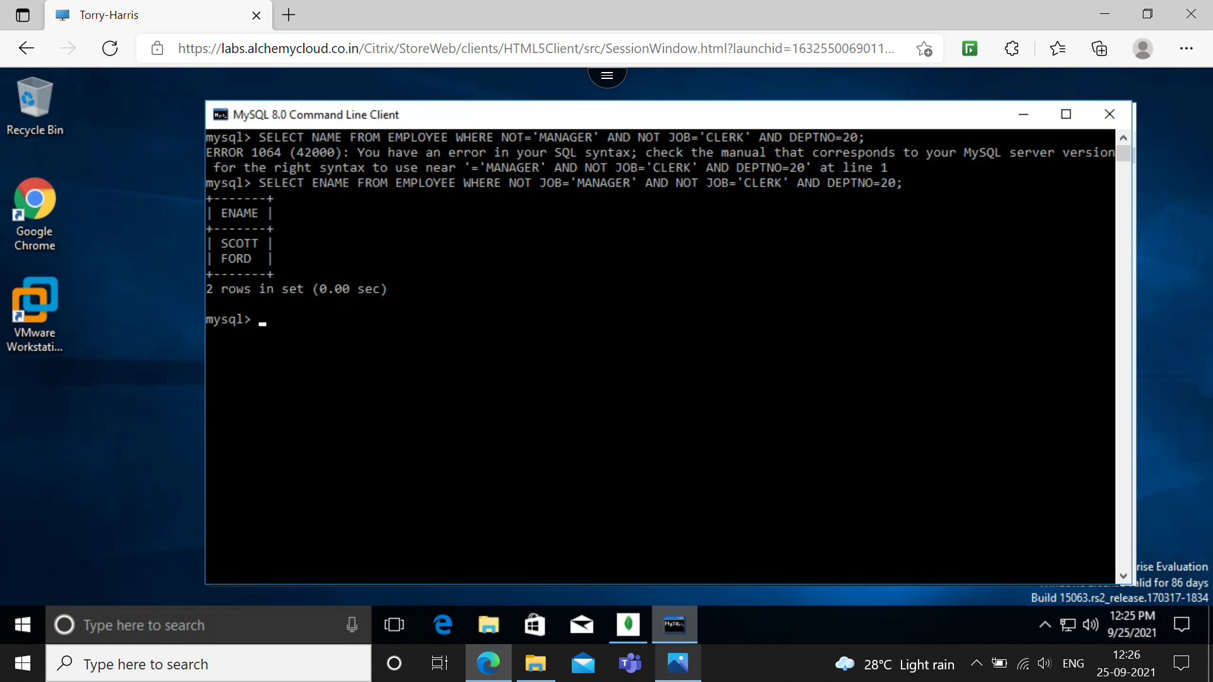

**Q15: FIND THE NAMES OF EMPLOYEES WHO EARN BETWEEN 1200 AND 1400**

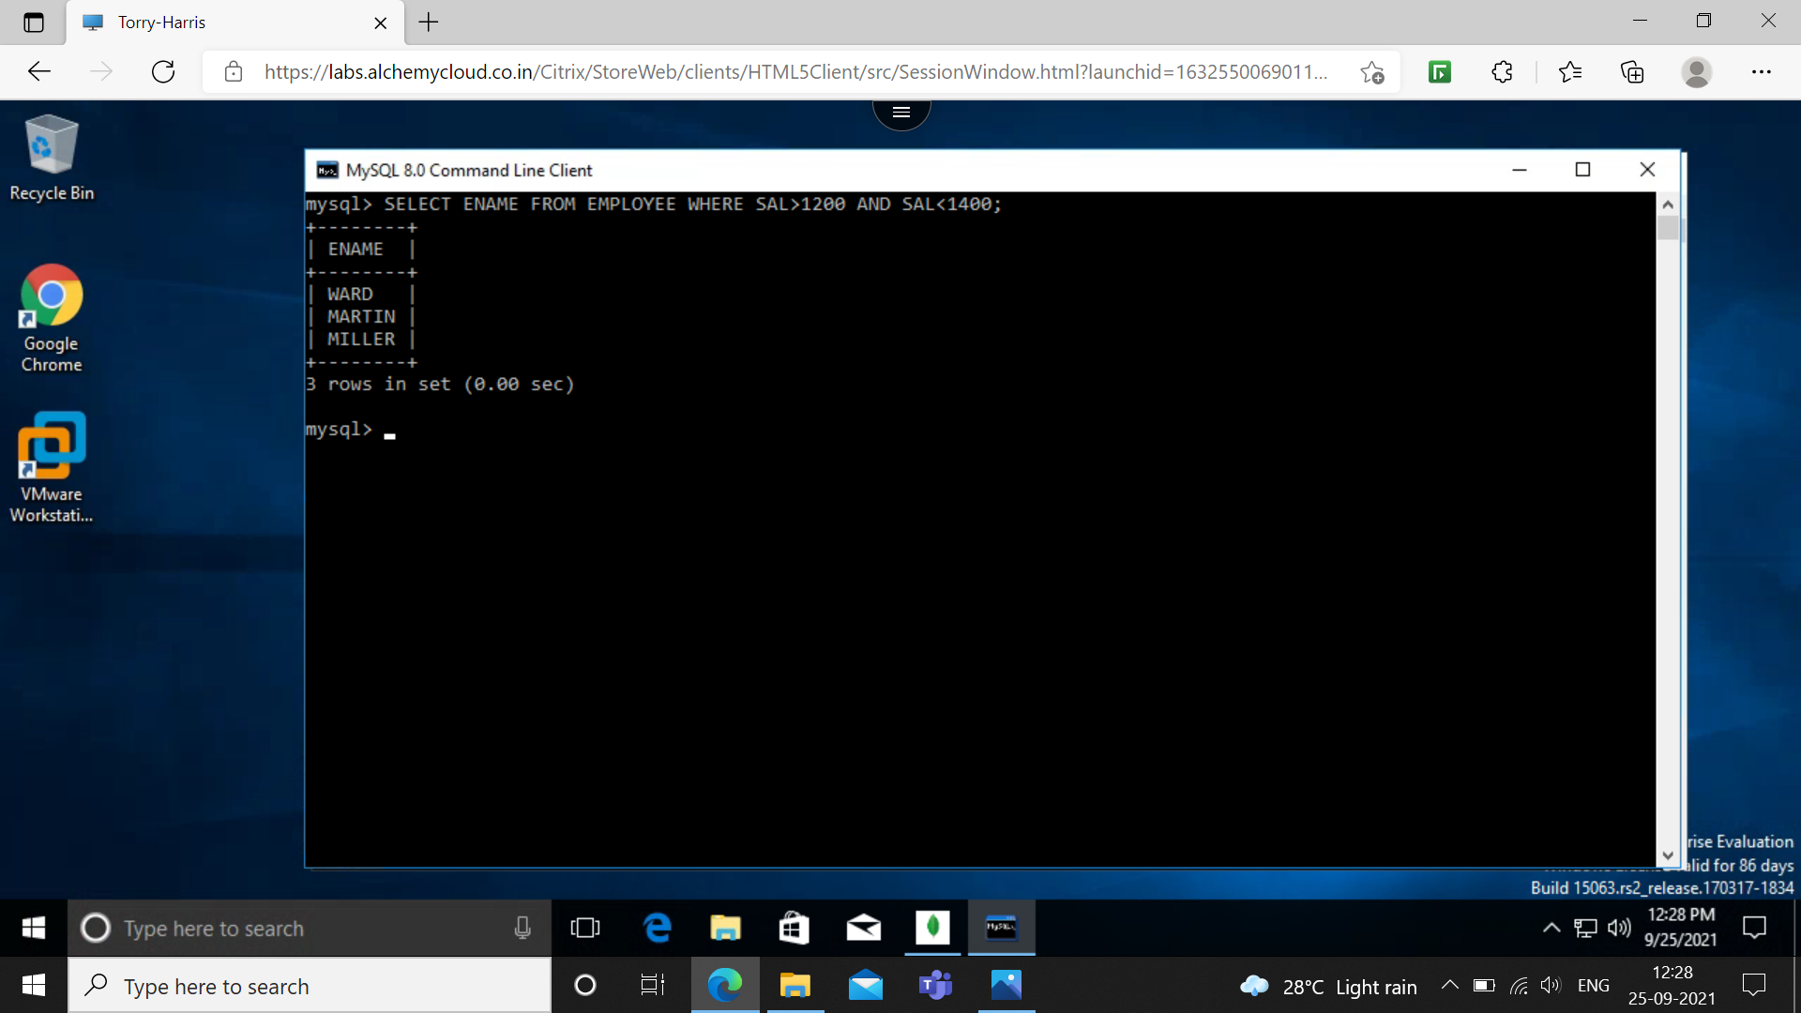

**Q16: FIND ALL THE EMPLOYEE WHO ARE CLERKS, ANALYST OR SALESMAN**

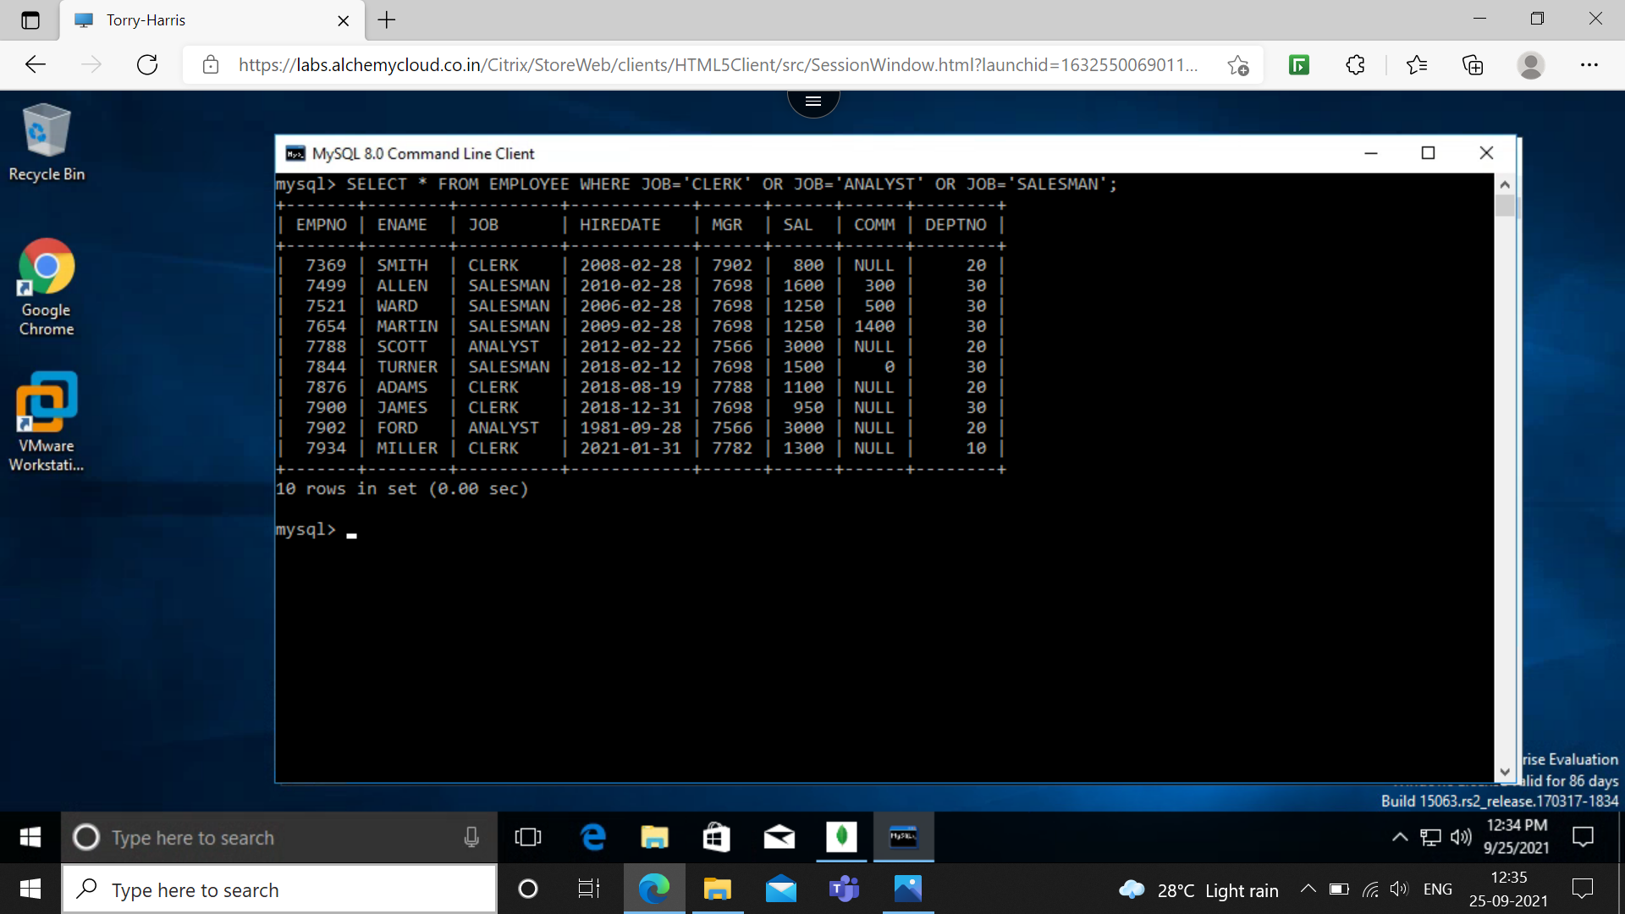

**Q17: FIND ALL THE EMPLOYEE WHO ARE NOT CLERKS, ANALYST OR SALESMAN**



**Q18: FIND THE EMPLOYEE WHO DO NOT RECEIVE COMMISSION**

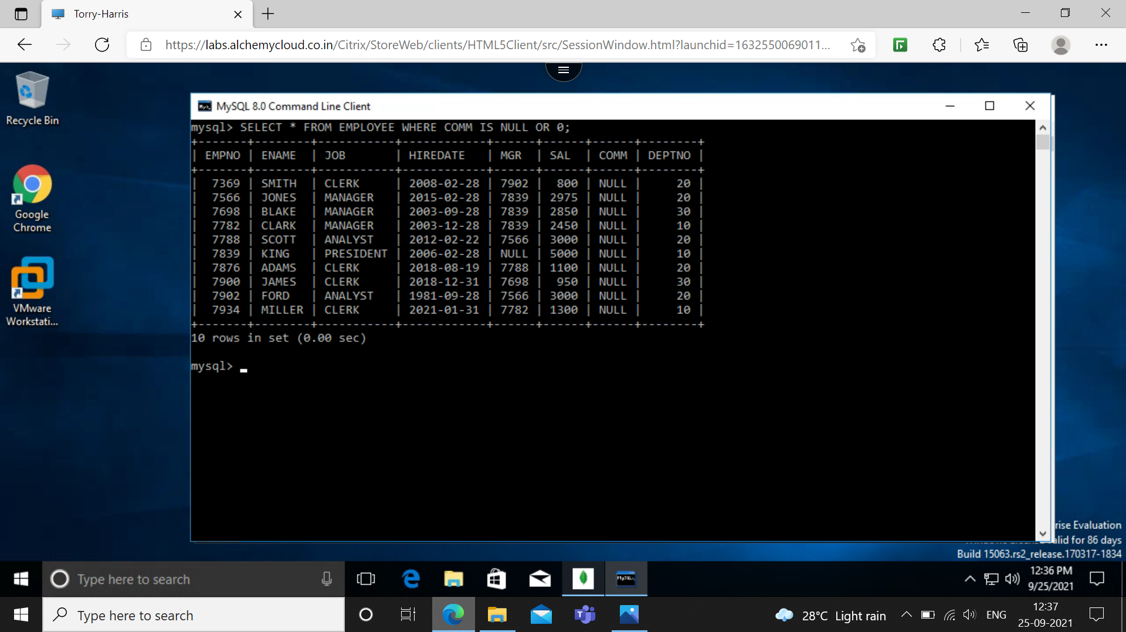

**Q19: FIND THE DIFFERENT JOBS OF EMPLOYEES RECEIVING COMMISION**

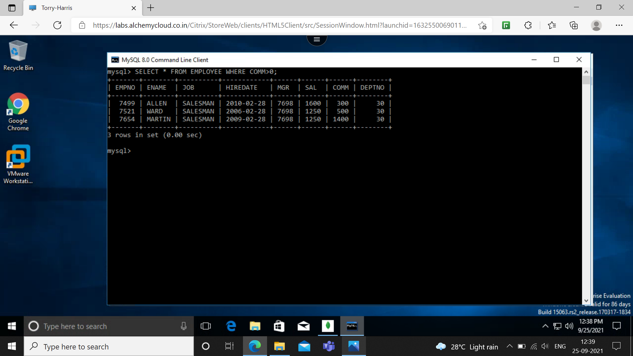

**Q20: FIND THE EMPLOYEES WHO DO NOT RECEIVING COMMISION OR WHOSE COMMISSION IS LESS THAN 100.**

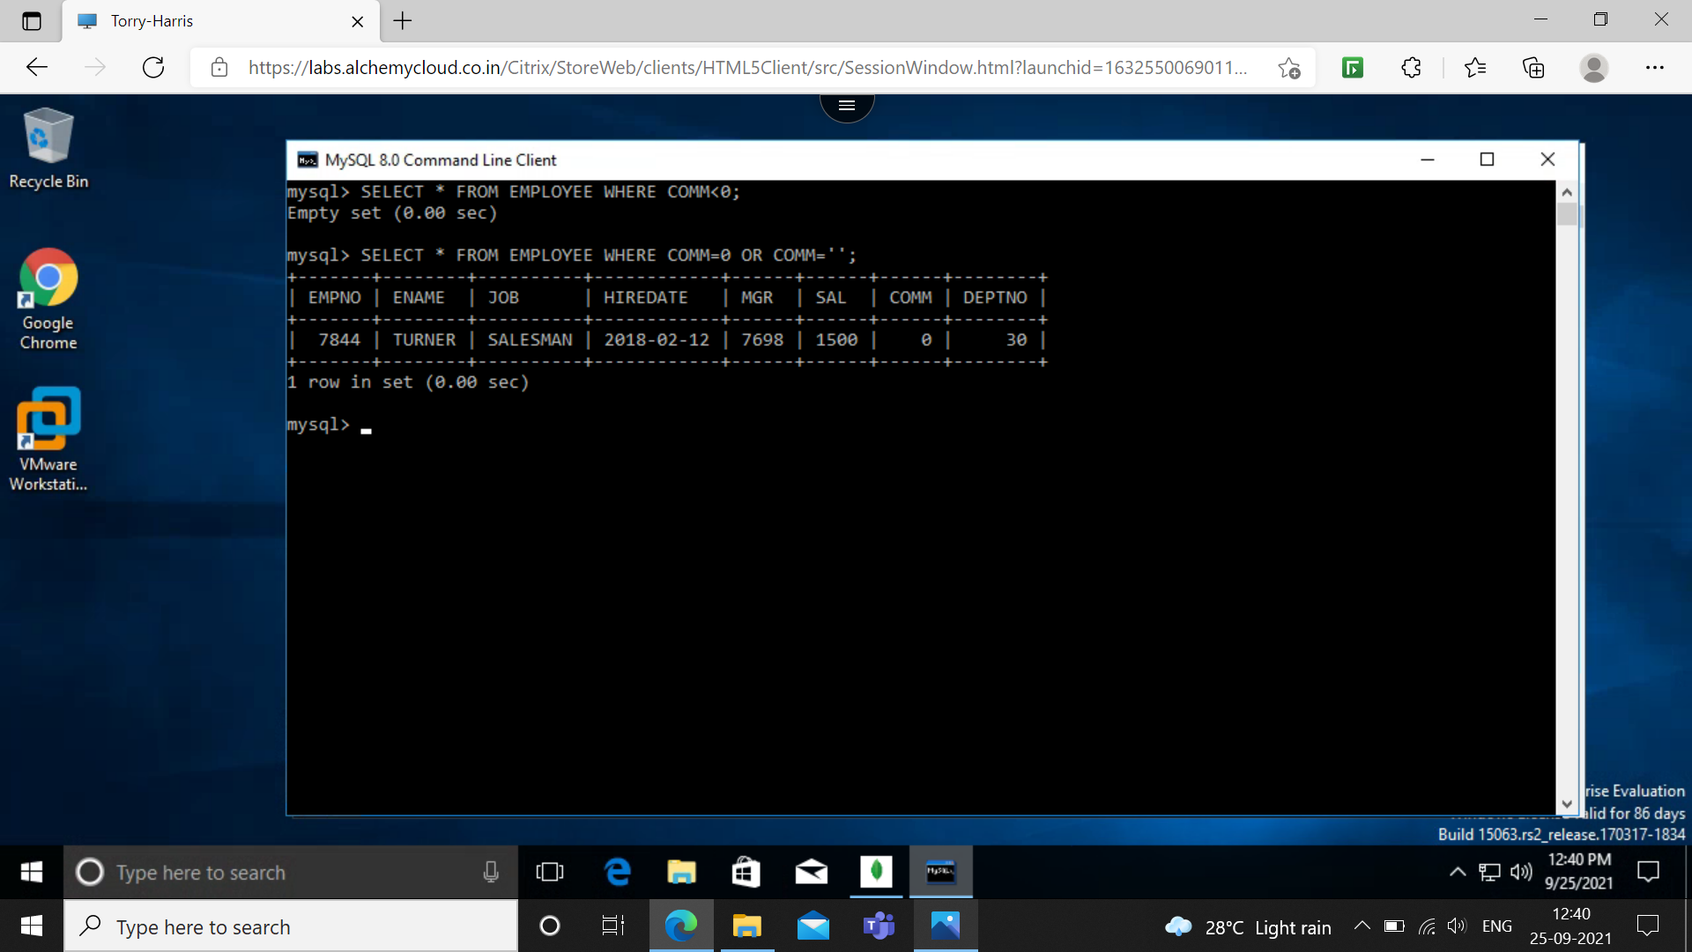

**Q21: IF ALL EMPLOYEE WHO DO NOT RECEIVING COMMISION IS ENTITLES TO A BONUS OF RS 250 SHOW THE NET EARNING OF ALL THE EMPLOYEES**

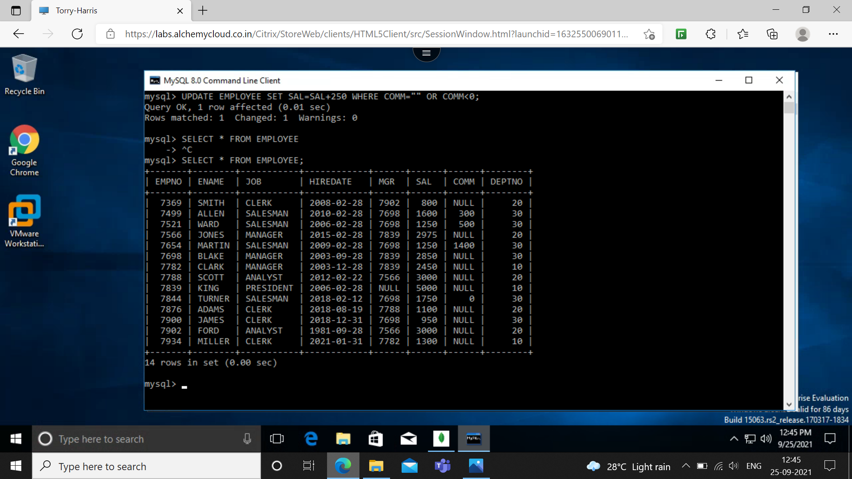

**Q22: FIND THE EMPLOYEE WHOSE TOTAL EARNING IS GREATER THAN 2000.**

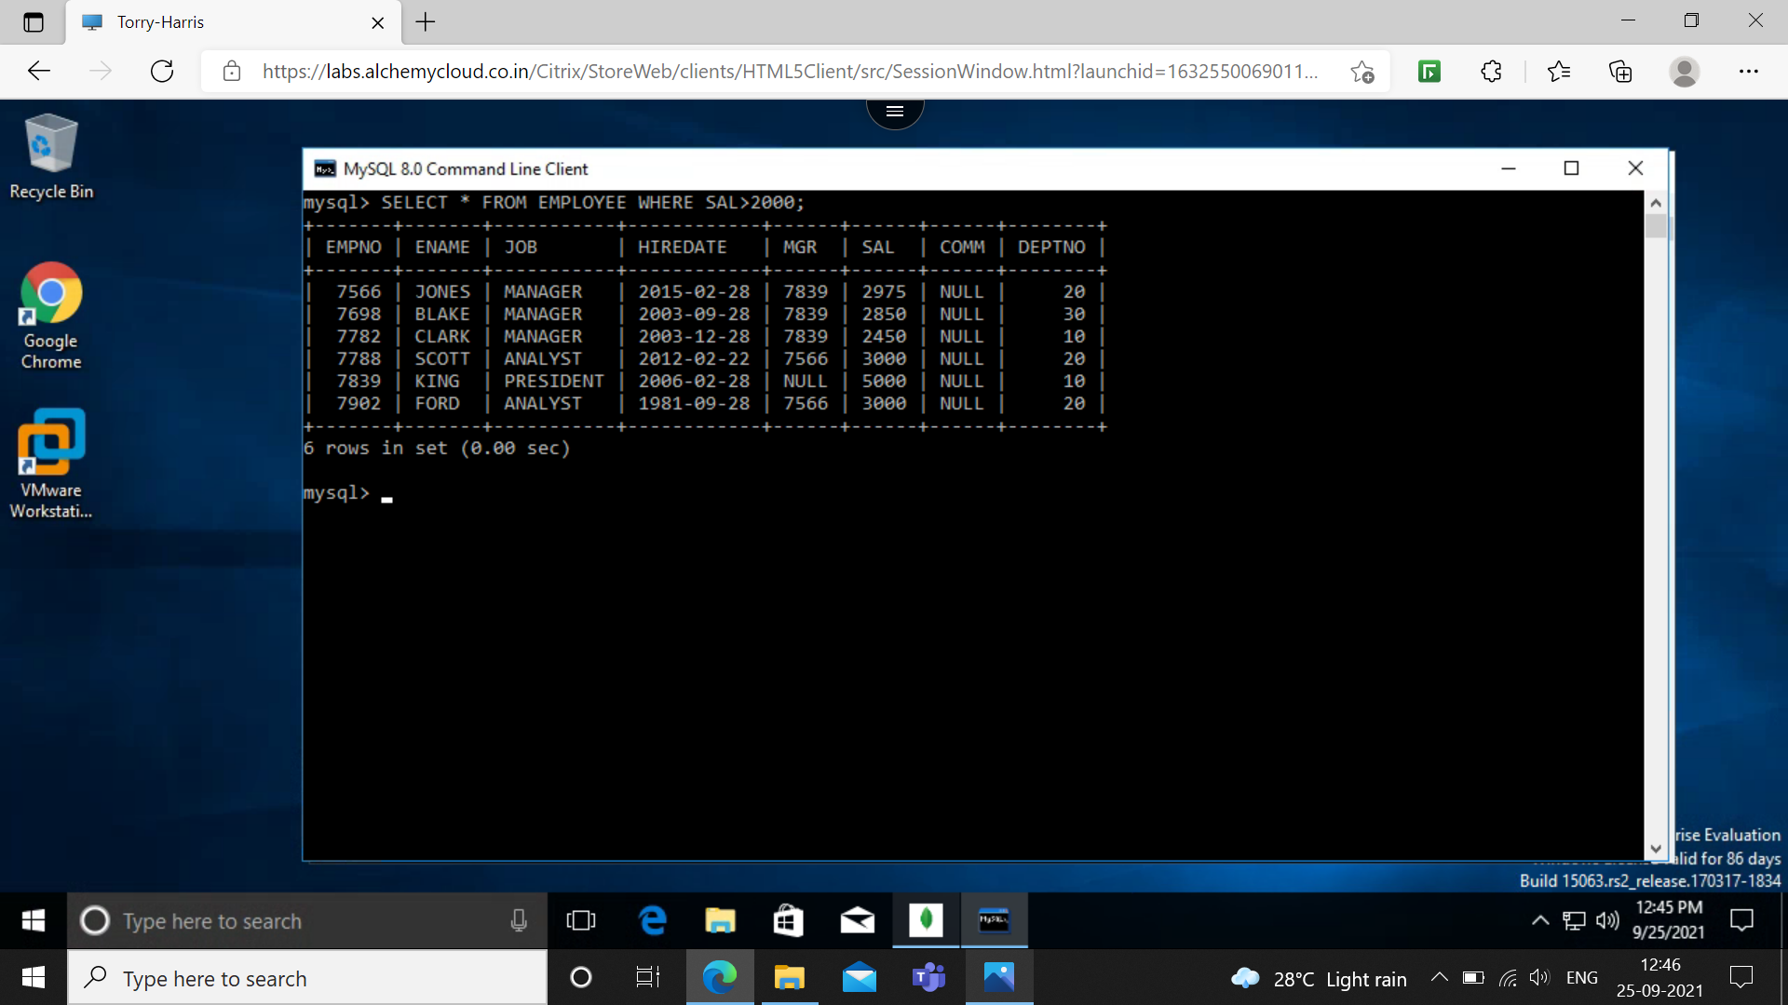

**Q23: FIND ALL THE EMPLOYEE WHOSE NAME BEGINS OR ENDS WITH ‘M’**

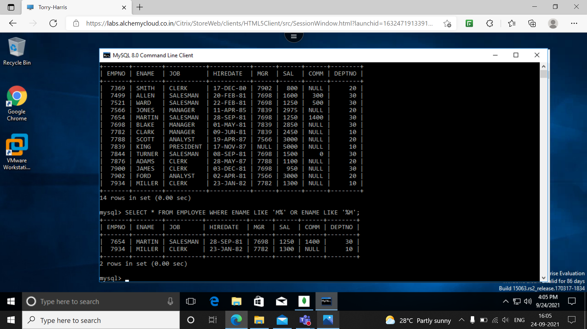

**Q24: FIND ALL THE EMPLOYEE WHOSE NAME CONTAINS WITH LETTER ‘M’ IN ANY CASE.**

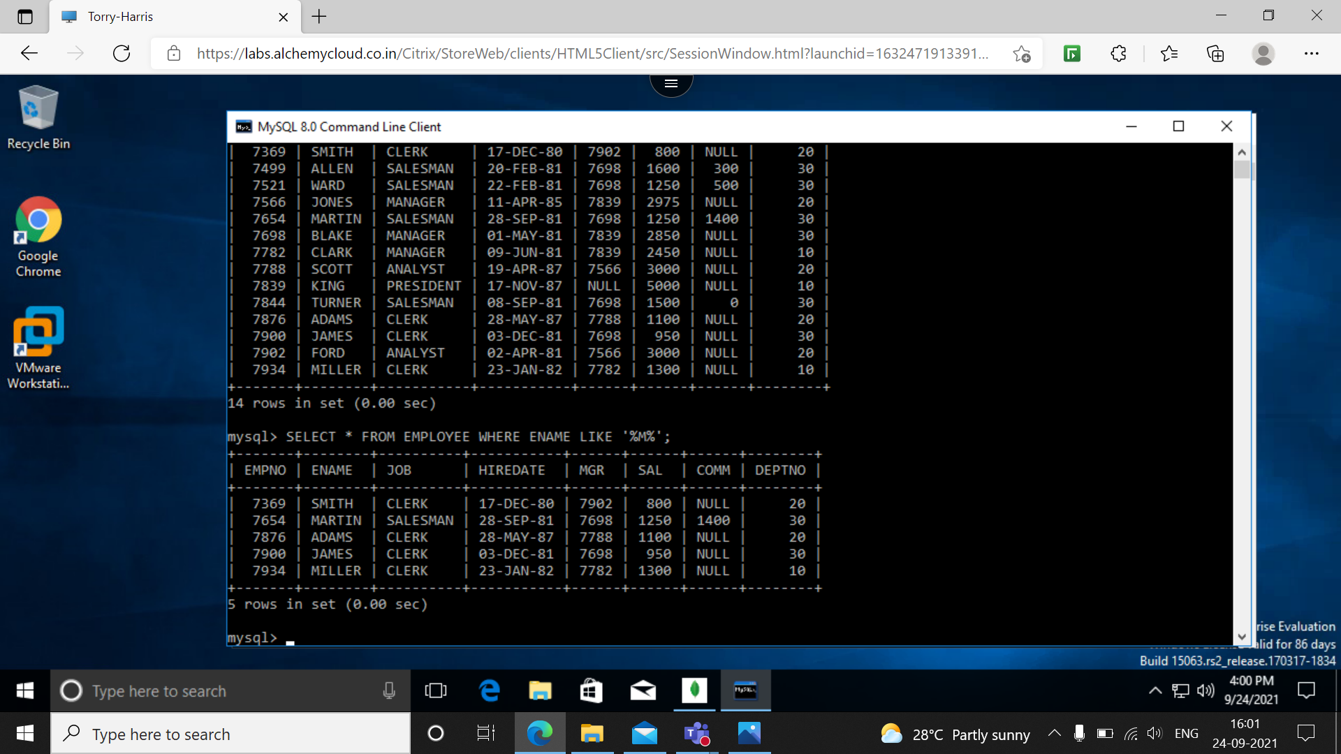

**Q25: FIND ALL THE EMPLOYEE WHOSE NAMES ARE UPTO 15 CHARACTER LONG AND HAVE LETTER ‘R’ AS 3 CHARACTER OF THEIR NAMES.** 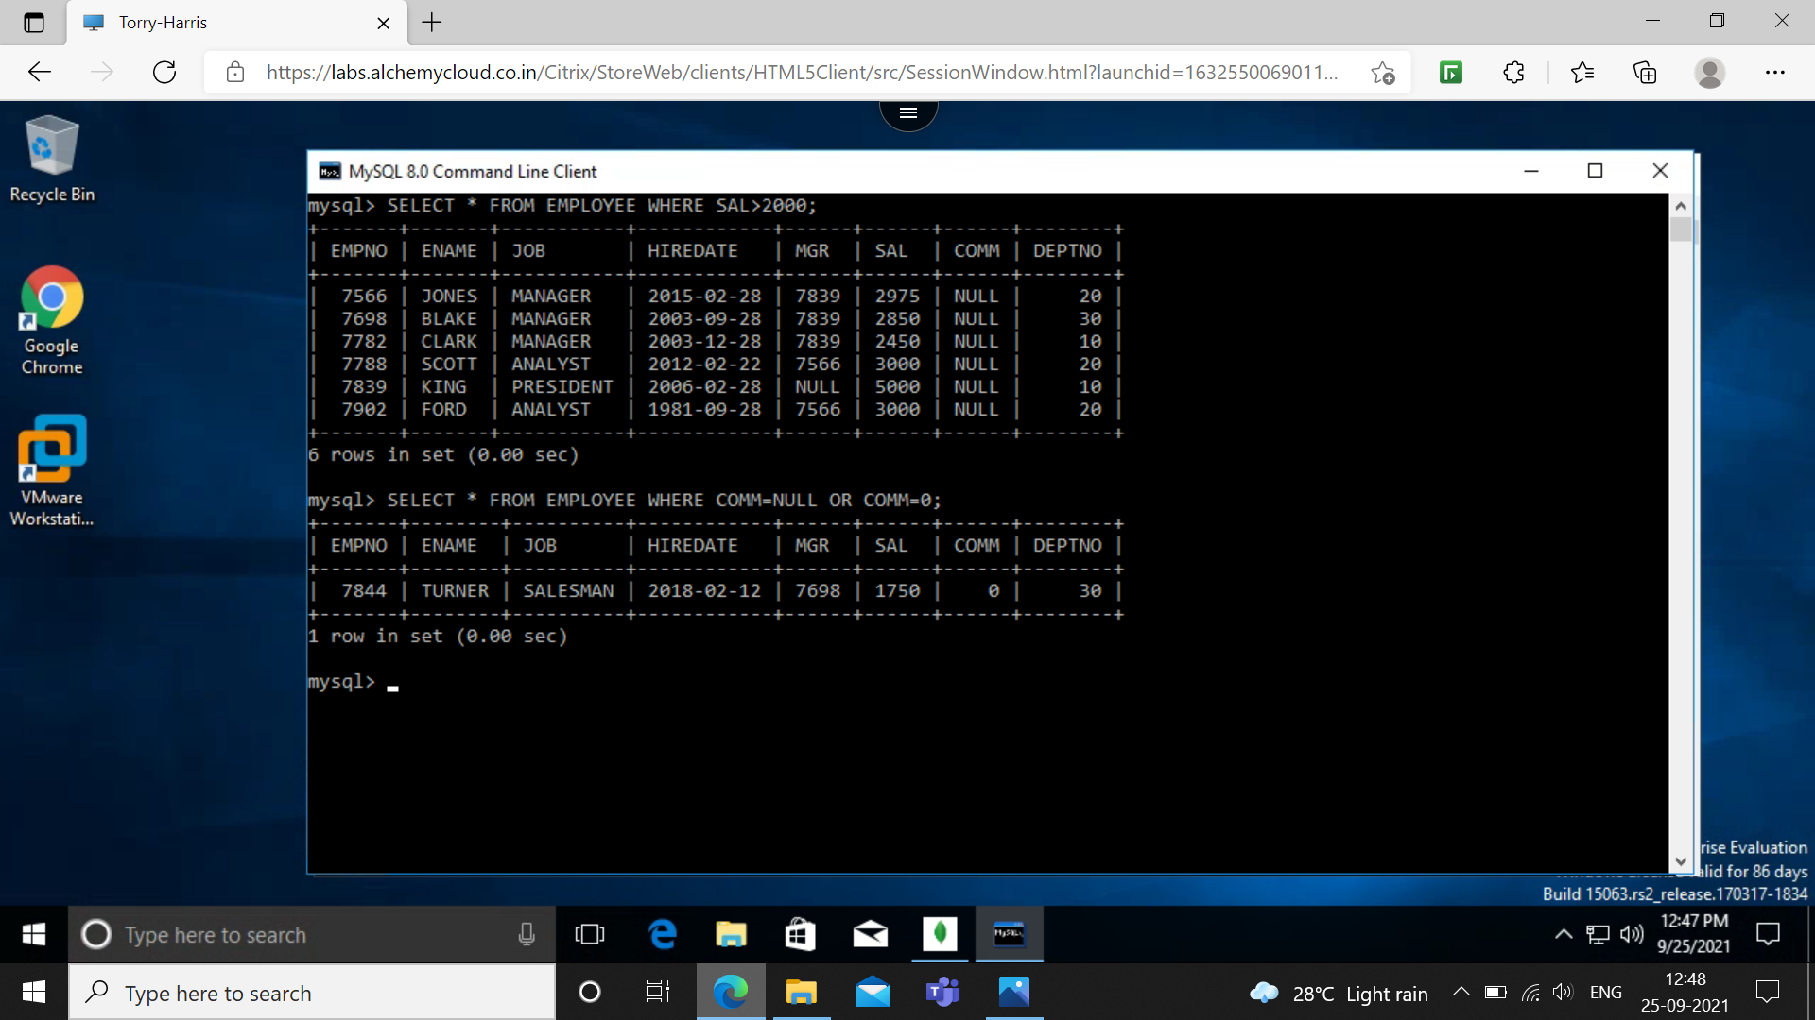

**Q26: FIND ALL THE EMPLOYEE WHO WERE HIRED IN THE MONTH OF FEBRUARY (OF ANY YEAR)** 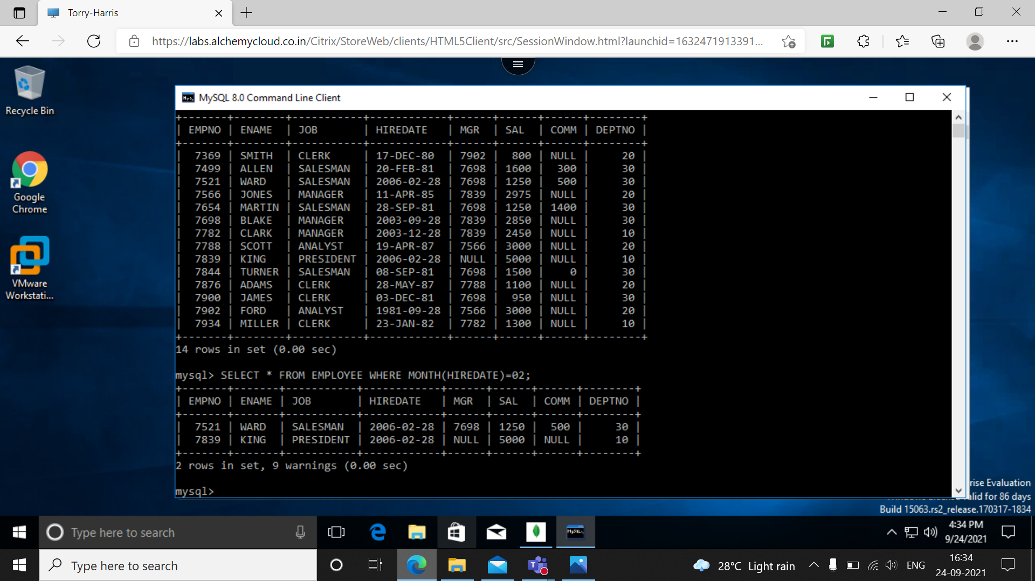

**Q27: FIND ALL THE EMPLOYEE WHO WERE HIRED ON LAST DAY OF THE MONTH**

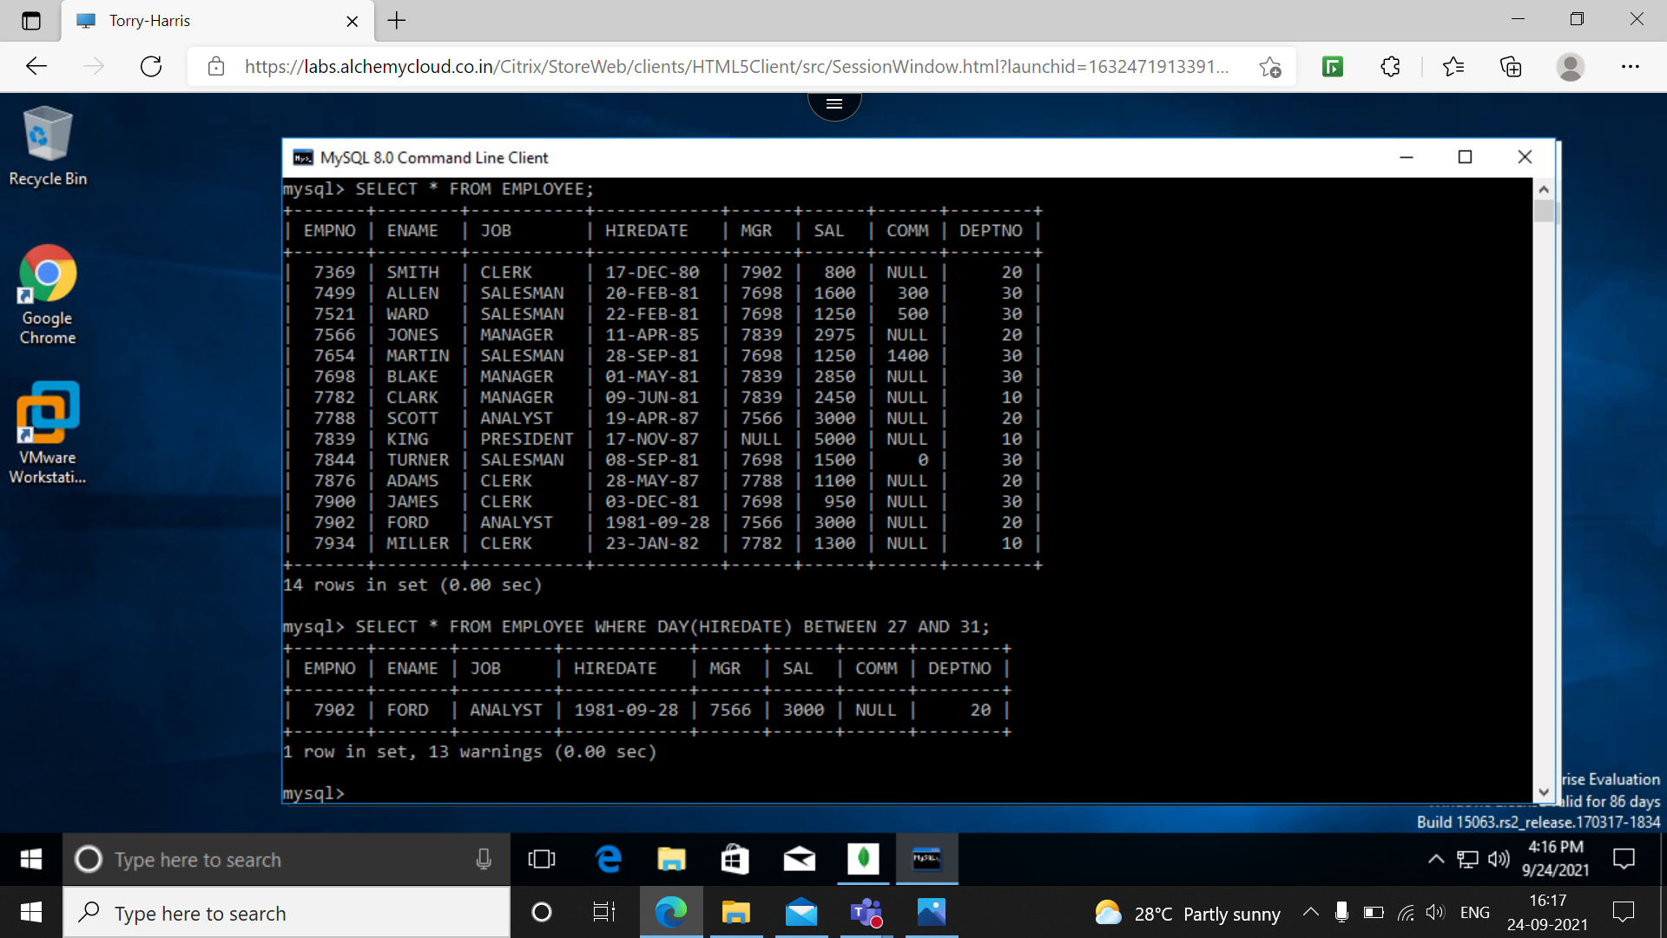

**Q28: FIND ALL THE EMPLOYEE WHO WERE HIRED MORE THAN 2 YEARS AGO**



**Q29: FIND ALL THE MANAGERS HIRED IN THE YEAR 2003**

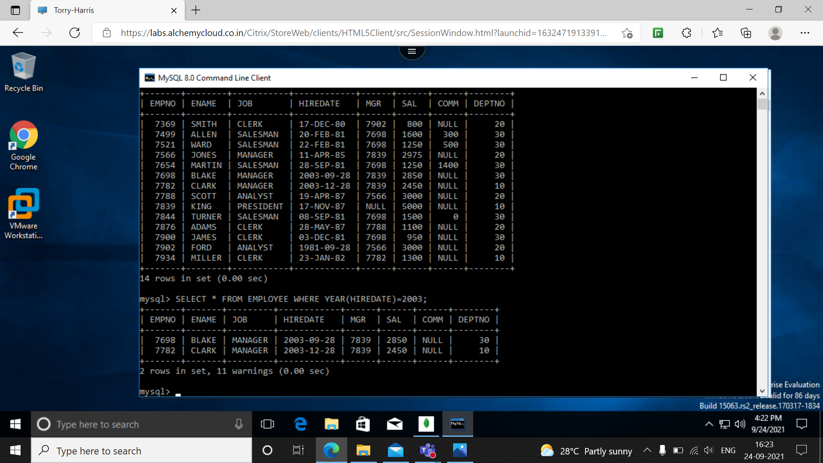

**Q30: DISPLAY YHE NAMES AND JOBS OF ALL THE EMPLOYEES SEPARATED BY THE SPACE**

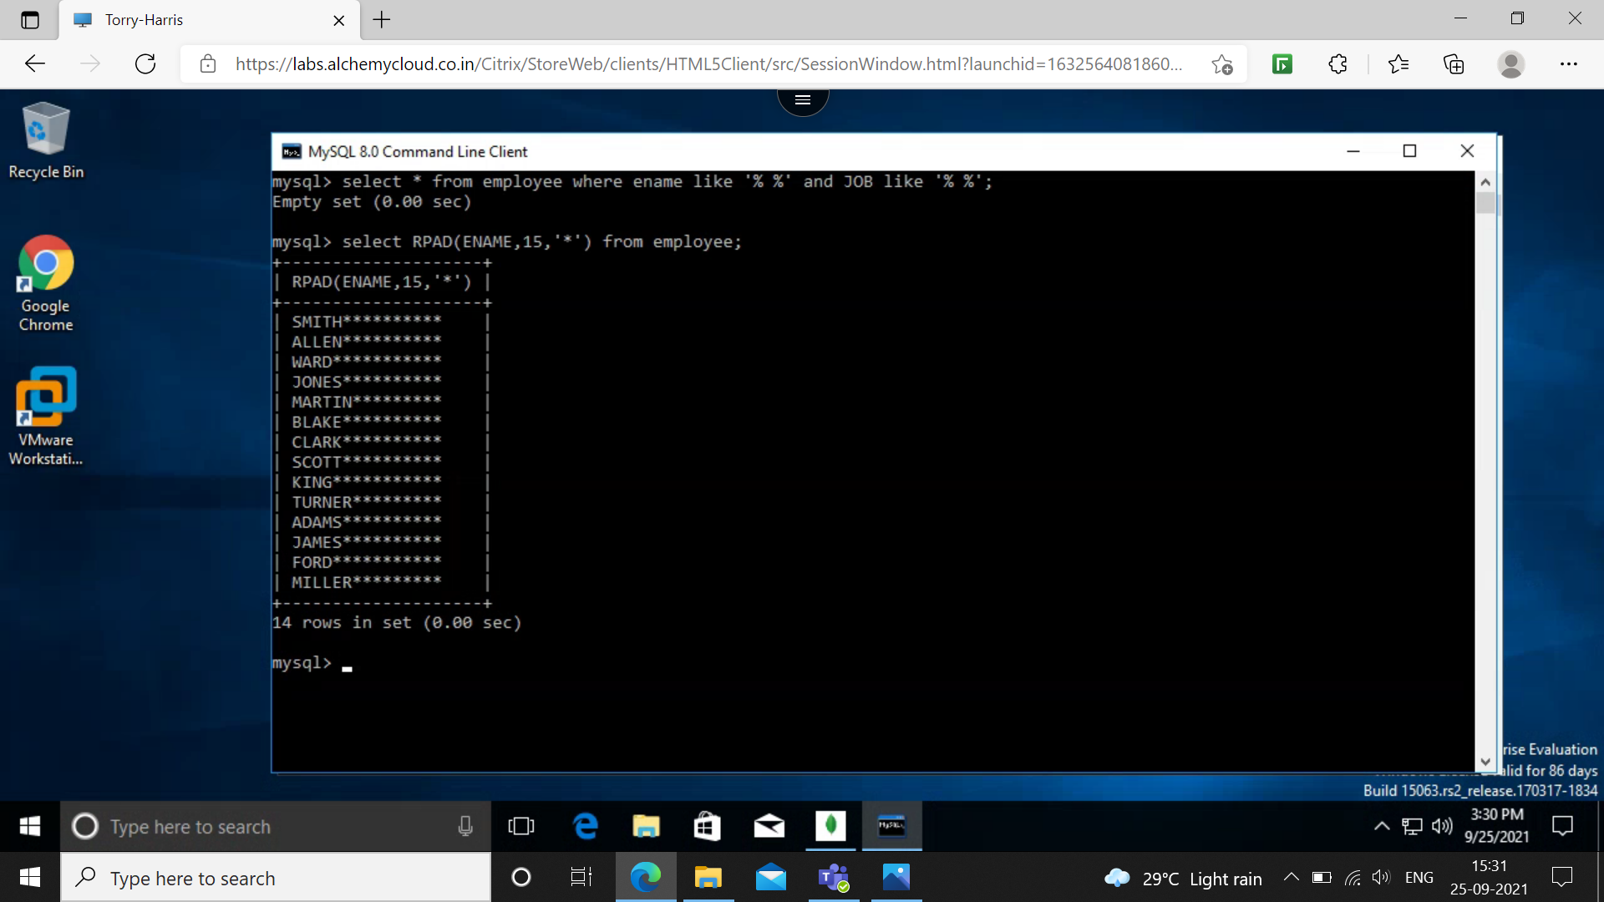

**Q31: DISPLAY YHE NAMES OF ALL THE EMPLOYEES RIGHT ALIGNING THEM TO 15 CHARACTERS.** 

**Q32: DISPLAY YHE NAMES OF ALL THE EMPLOYEES PADDING THEM TO THE RIGHT UP TO 15 CHARACTERS WITH *.**



**Q33: DISPLAY THE NAMES OF ALL THE EMPLOYEES WITHOUT ANY LEADING ‘A’.**

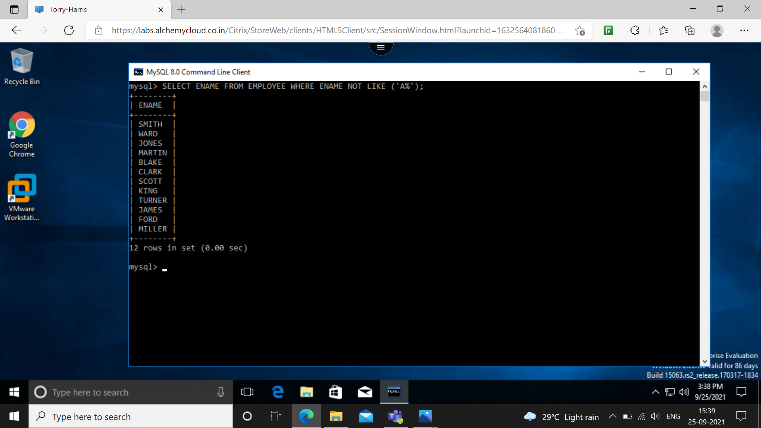

**Q34: DISPLAY THE NAMES OF ALL THE EMPLOYEES WITHOUT ANY TRAILING ‘R’.**

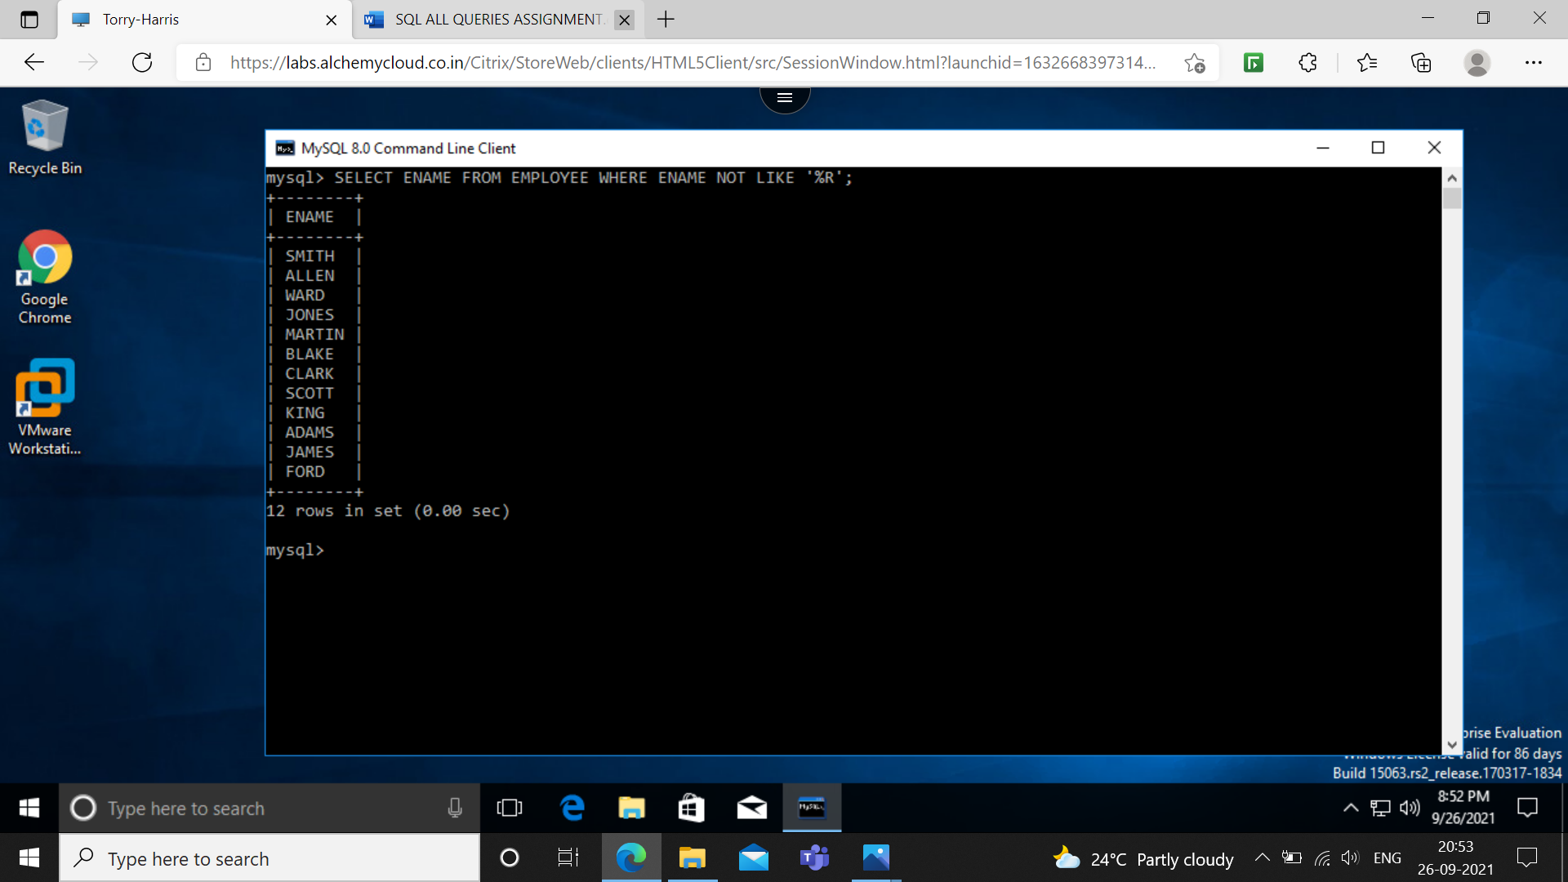

**Q35: SHOW THE FIRST 3 AND LAST 3 CHARACTERS OF THE NAMES OF ALL THE EMPLOYEES.**

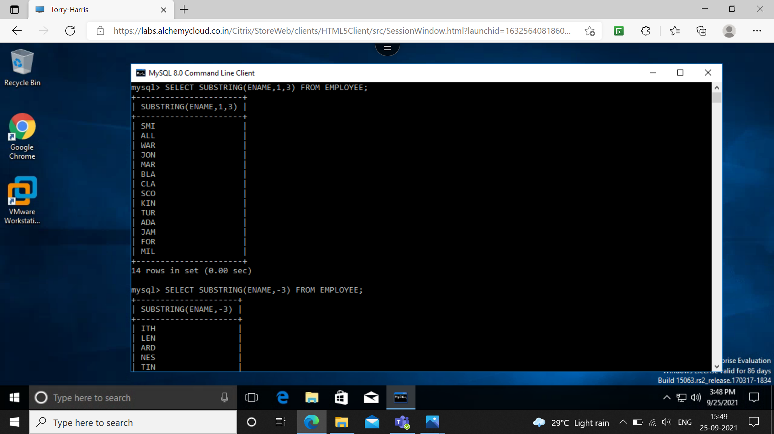

**Q36: SHOW THE FIRST 3 AND LAST 3 CHARACTERS OF THE NAMES OF ALL THE EMPLOYEES.**

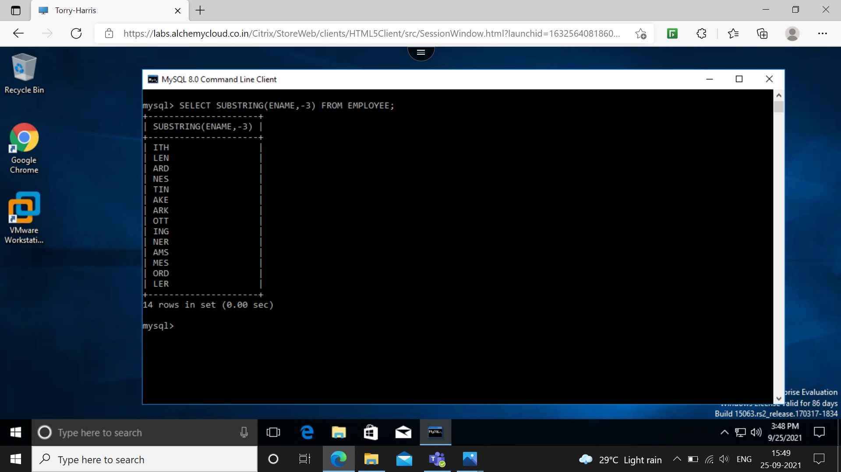

**Q37: DISPLAY THE NAMES OF ALL THE EMPLOYEES AND POSITION WHERE THE STRING ‘AR’ OCCURS IN THE NAME.**

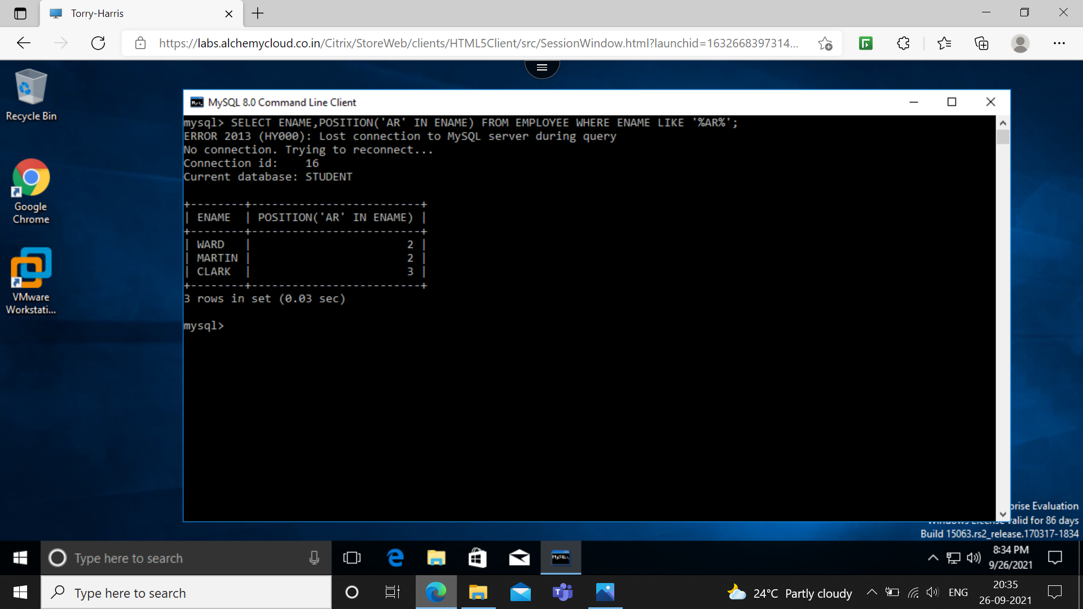

**Q38: SHOW THE SALARY OF ALL THE EMPLOYEES, ROUNDING IT TO THE NEAREST RS 1000.**

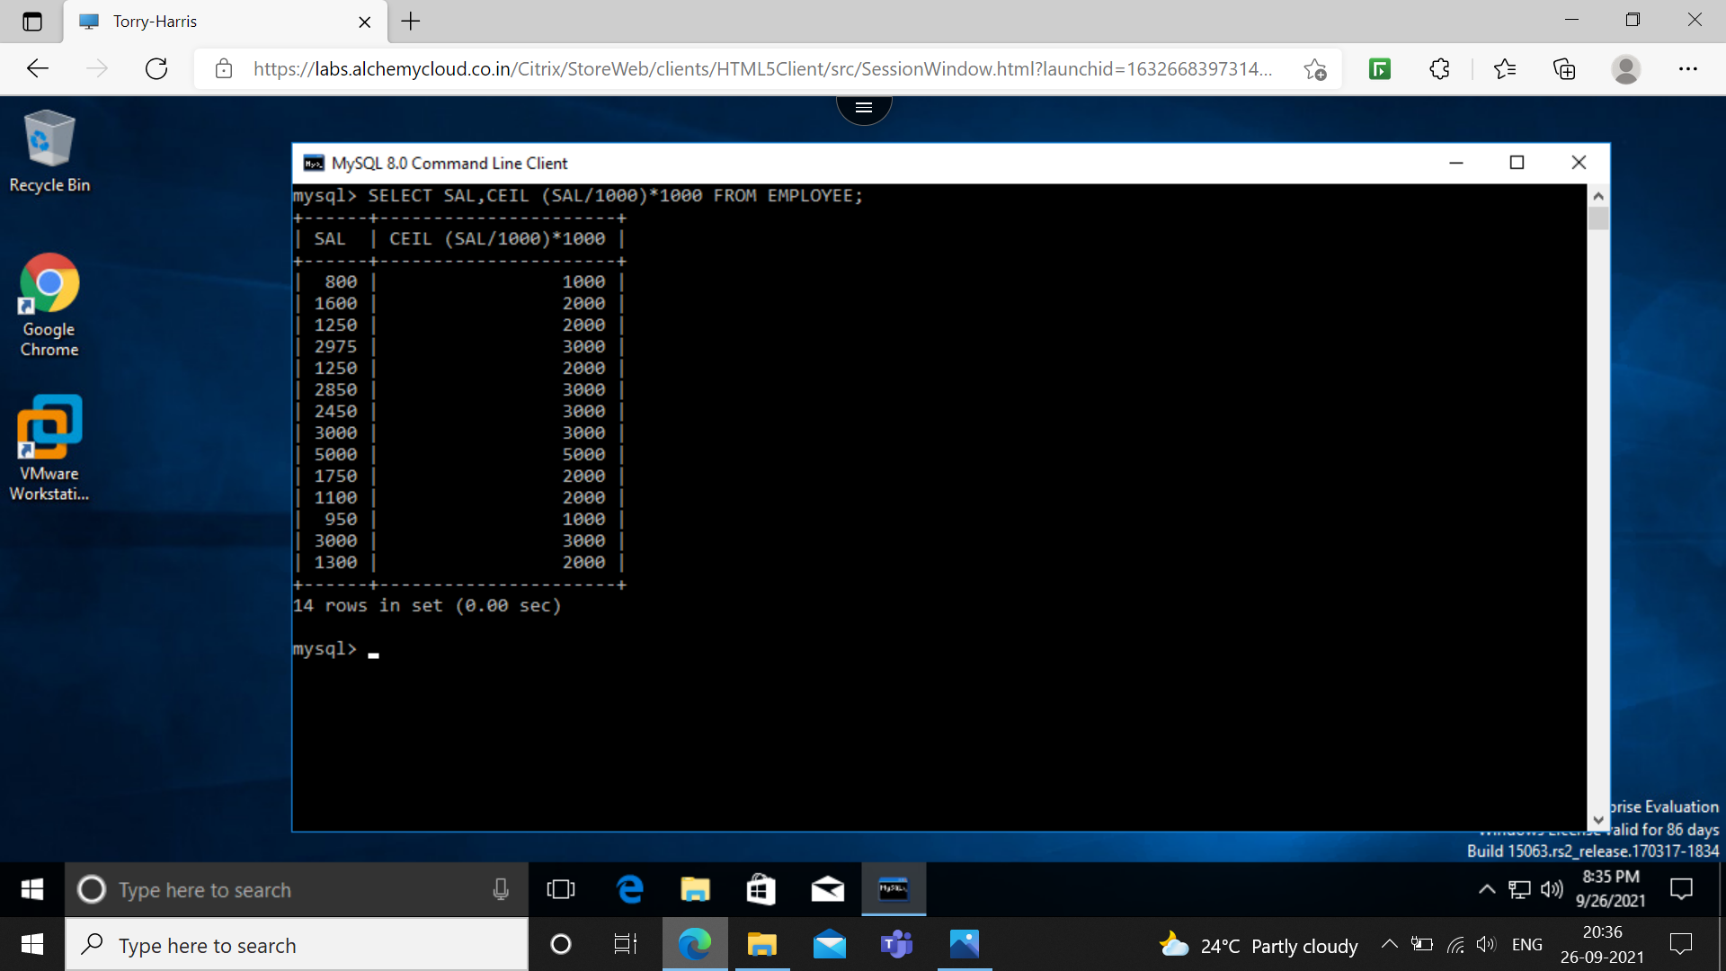

**Q40: SHOW THE NAMES OF ALL THE EMPLOYEES AND DATE ON WHICH THEY COMPLETED 3 YEARS OF SERVICE.**

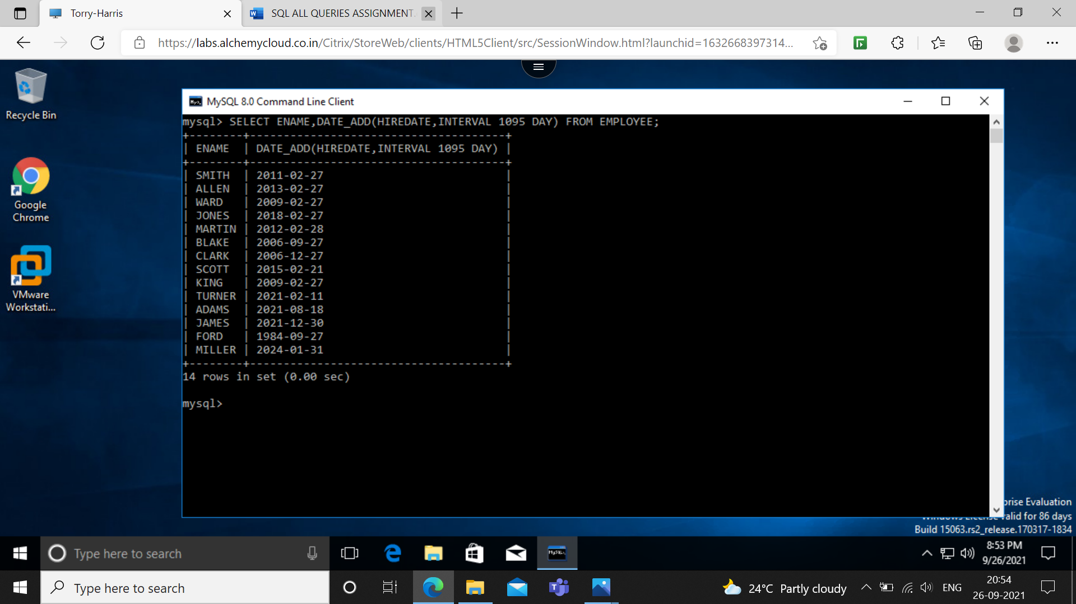

**Q41: FOR EACH EMPLOYEE, DISPLAY THE NO OF DAYS PASSED SINCE THE EMPLOYEE JOINED THE EMPLOYEE.**

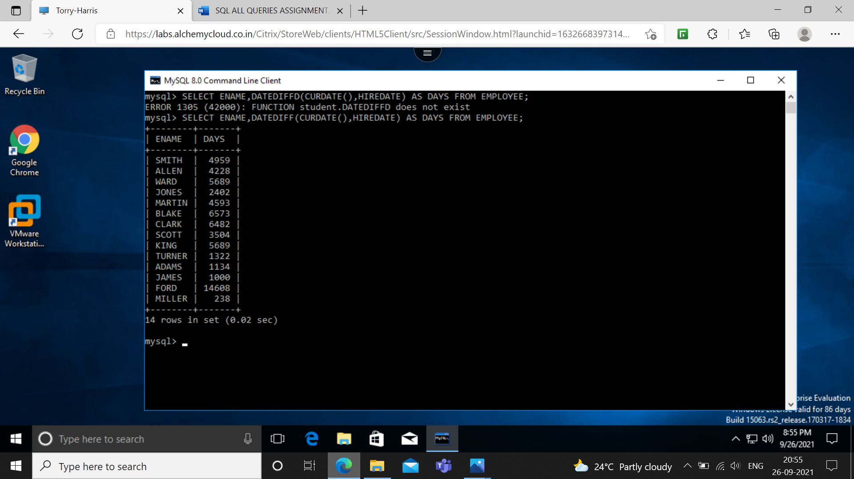

**Q42: FOR EACH EMPLOYEE, DISPLAY THE NO OF MONTHS PASSED SINCE THE EMPLOYEE JOINED THE EMPLOYEE.**

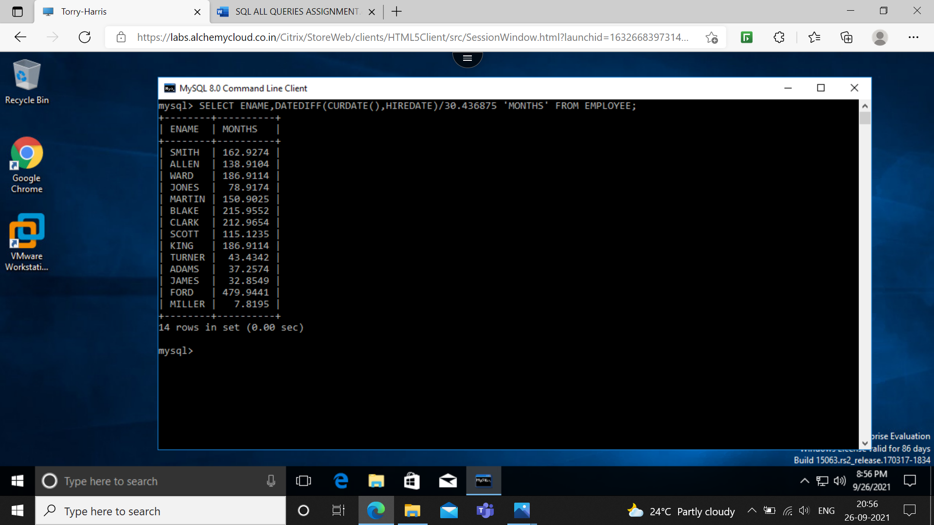

**Q43: DISPLAY THE DETAILS OF ALL THE EMPLOYEES SORTED ON THE NAME.**

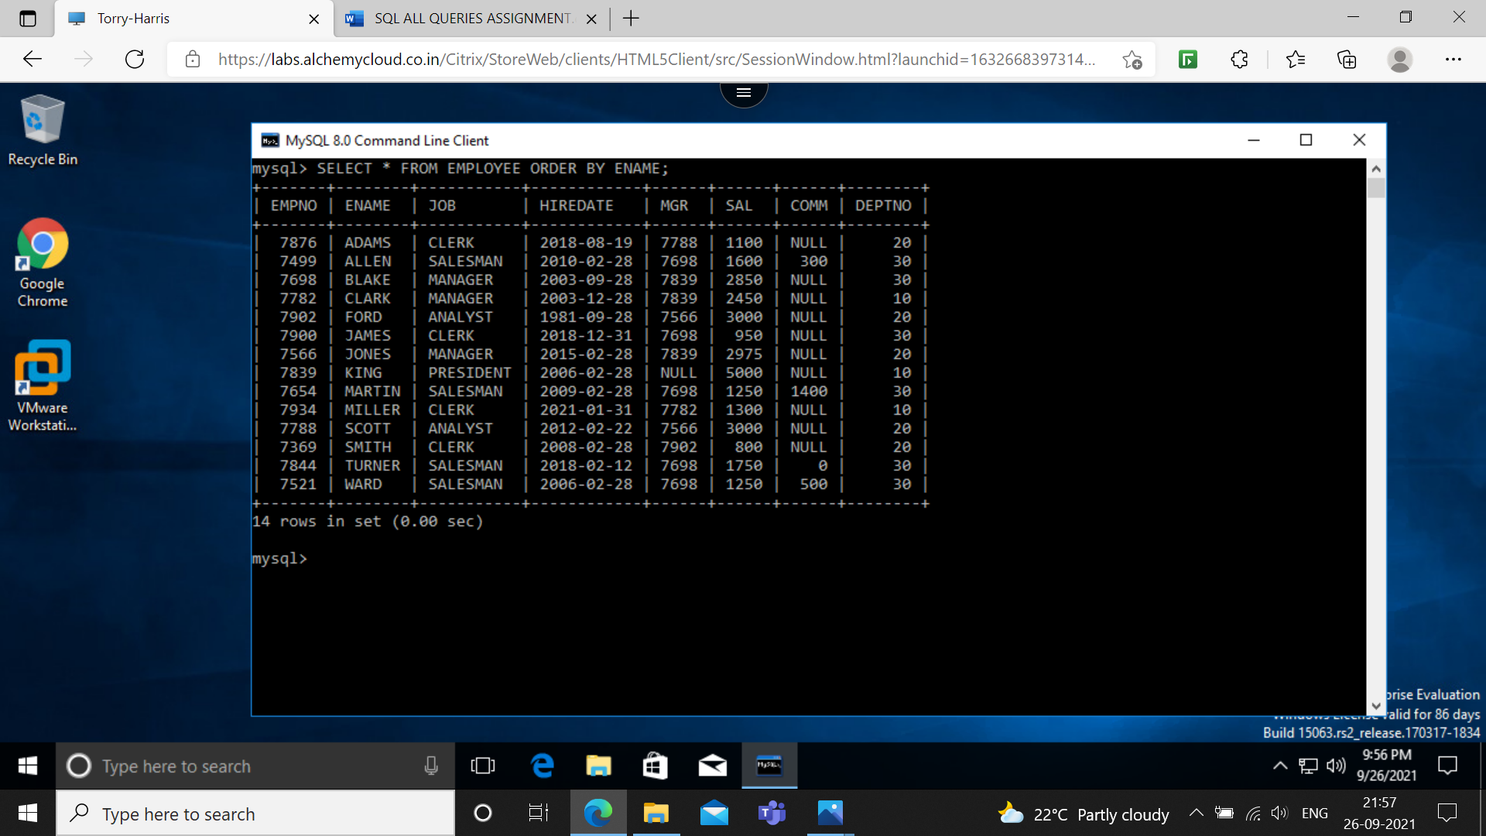

**Q45: DISPLAY THE NAMES, JOBS AND SALARIES OF EMPLOYEE SORTING ON JOB AND SALARY.**

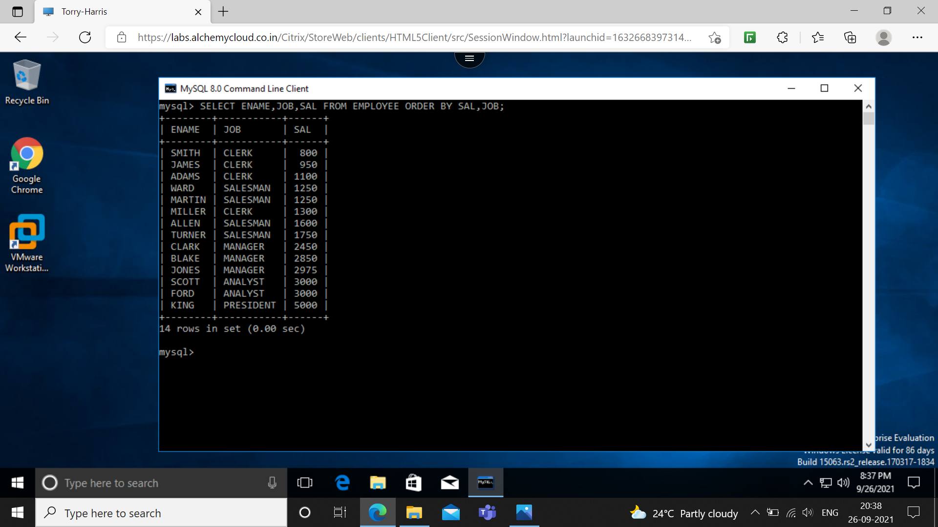

**Q46: DISPLAY THE NAMES, JOBS AND SALARIES OF EMPLOYEE SORTING ON DESCENDING ORDER OF JOB AND WITHIN JOB SORTED ON SALARY.**

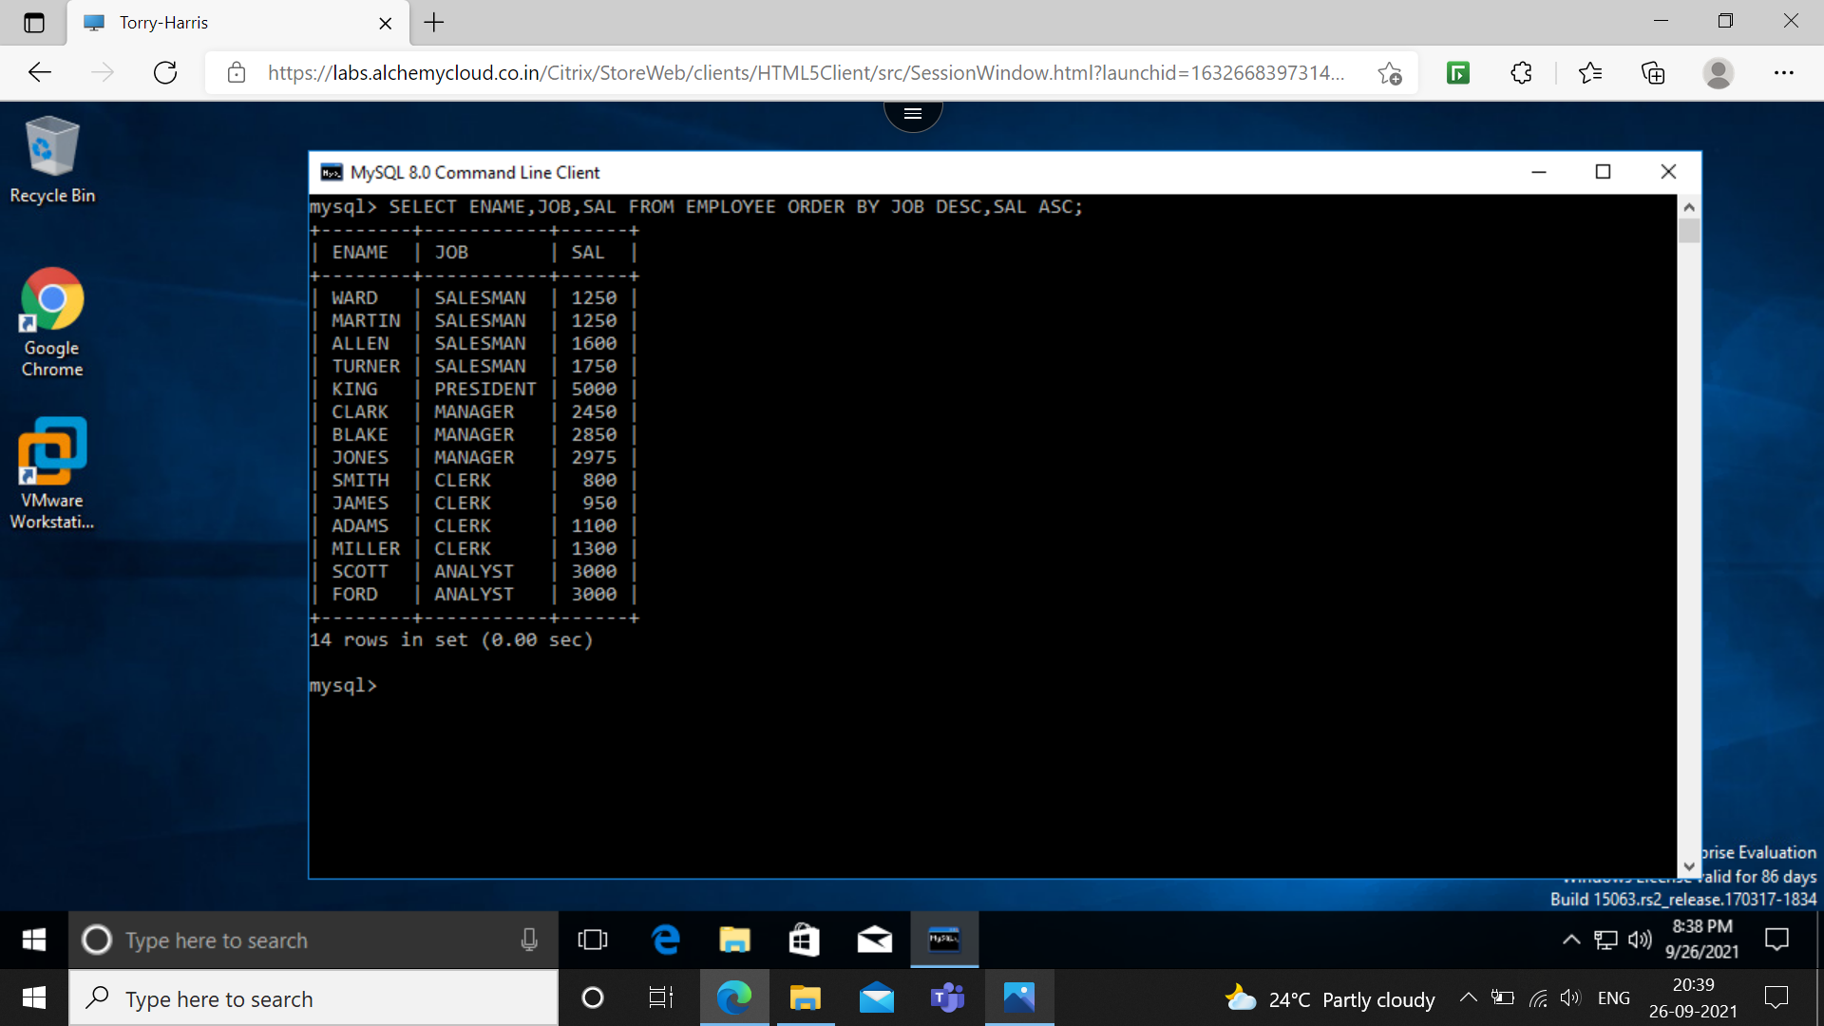

**Q48: LIST THE EMPLOYEE NAME, DEPARTMENT NAMES AND HIREDATE FOR THOSE EMPLOYEES WHO ARE EARNING 0 COMMISION OR COMMISION IS NULL. SORT YOUR OUTPUT IN THE ORDER OF DEPARTMENT NAME.**

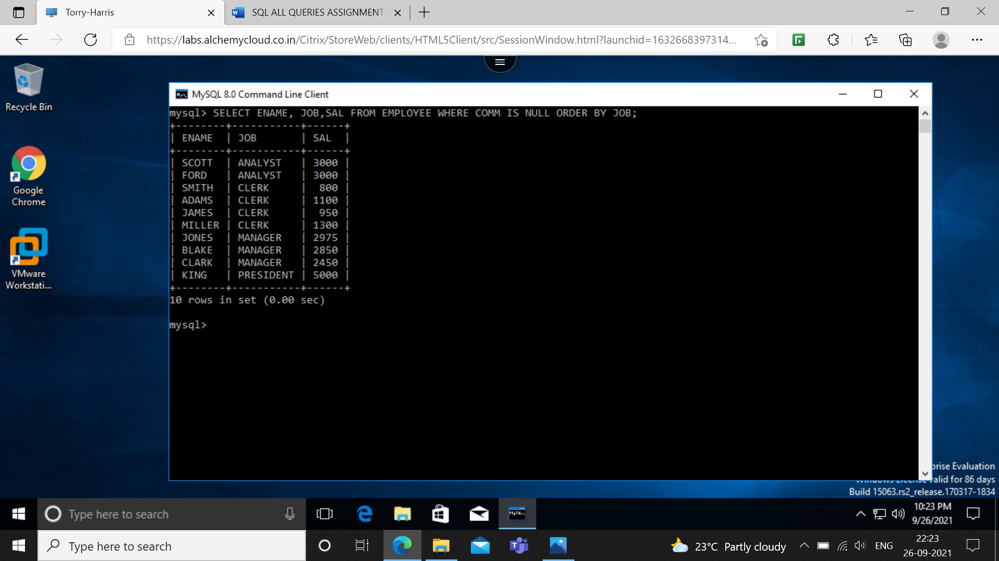

**Q49: LIST THE EMPLOYEE NAME, DEPARTMENT NAMES AND HIREDATE FOR THOSE EMPLOYEES WHO HAVE JOINED IN 2003. SORT YOUR OUTPUT IN THE ORDER OF JOINING DATE.**

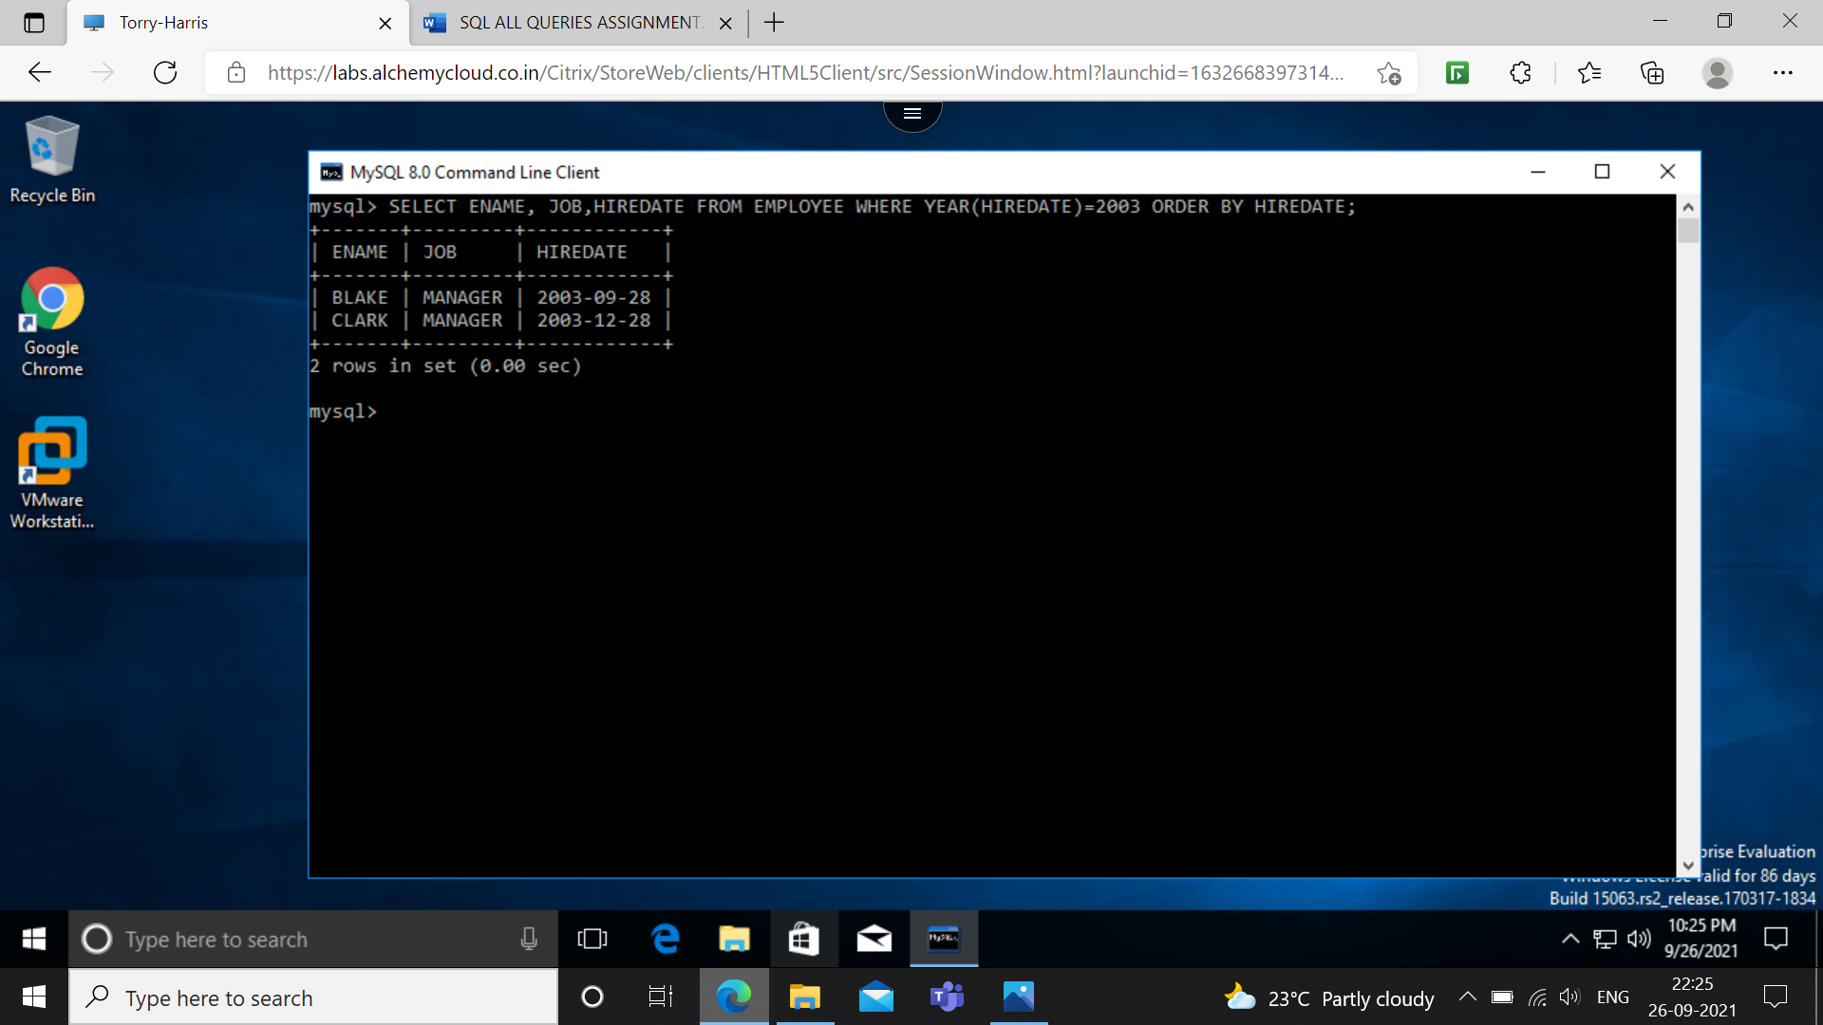

**Q50: LIST ALL THE DEPARTMENT NAMES ALONG WITH THE NAMES OF EMPLOYEES IN THEM, IRRESPECTIVE OF THE FACT WHETHER ANY EMPLOYEE IS THERE OR NOT.**

